The Worshipful Company of Upholders 2024 travel bursary report

The Lady Lever Art Gallery
The Lady Lever Art Gallery (LLAG) has one of the most significant collections of fine and decorative art in the UK. It opened in 1922 and remains the only major public gallery built in Britain to house the personal art collection of its founder, William Hesketh Lever (1851-1925).

Lever’s large collection of English pictorial embroideries of the 17th and 18th centuries reflects his interest in the domestic, even amateur, craftsmanship of ordinary women. His belief in art as an ingredient of everyday life was a cliché of the Arts and Crafts aesthetic which had developed as Lever grew to manhood. The attraction of embroidery to Lever the collector was two-fold; it assuaged his need for domestic beauty in his own residencies and gave an instructive insight into the domestic life of the past. For him, the embodiment of the humblest, hearth-centred, and home-making art was the embroidered picture.

Proposal for a May Morris exhibition at the Lady Lever Art Gallery
May Morris (1862-1938), the younger daughter of William Morris, is recognised today as a leading figure in the Arts and Crafts movement. An accomplished needlewoman, she became the manager of Morris & Co’s embroidery department at the age of 23. In 2026 the Lady Lever Art Gallery will host an exhibition about May Morris, in celebration of her wide-ranging talents. It will showcase a selection of her embroideries (alongside wallpaper, woodblock prints, watercolour designs, jewellery and publications), on loan from The William Morris Society and other UK collections.

The exhibition design will evoke the Arts and Crafts period with bold forms and strong colours, and patterns based on flora and fauna. Wall graphics will represent key people in May’s artistic and literary circles, iconic Arts and Crafts buildings such as Red House and Kelmscott Manor, and a range of hand-craft decorative art objects of the period. Film footage will demonstrate different embroidery techniques.

This exhibition presents National Museums Liverpool with an exciting opportunity to display, for the first time, Arts and Crafts objects from its collection, including a late 19th-century table cover decorated with peacocks, sunflower and rising sun motifs. Rarely seen objects from Lever’s embroidery collection, conserved prior to display, will exemplify the needlework skills of English girls in the 17th and 18th centuries whose work May Morris admired. Committed to reviving historic stitch, she was hugely influential in elevating needlework from a domestic craft to a serious art form.

Travel bursary
A travel bursary generously awarded by the Worshipful Company of Upholders has enabled me to undertake curatorial research visits to a variety of pertinent museums, galleries, houses and libraries in London, Kent, Oxford and Oxfordshire. In October 2024 I travelled to London to visit the National Art Library at the V&A Museum, Emery Walker’s House, Kelmscott House, and the William Morris Gallery including its archives; in Kent I visited Red House; and two weeks later I travelled to Oxfordshire where I visited Kelmscott Manor, and to Oxford for the Western Art Print Room at the Ashmolean Museum.

I have created PowerPoint presentations for six of these visits (excluding Emery Walker’s House which did not permit photography). These richly illustrated presentations capture the highlights of each visit and will serve as a visual record for myself and colleagues when developing the May Morris exhibition at the LLAG over the next 18 months.

National Art Library, V&A Museum, London
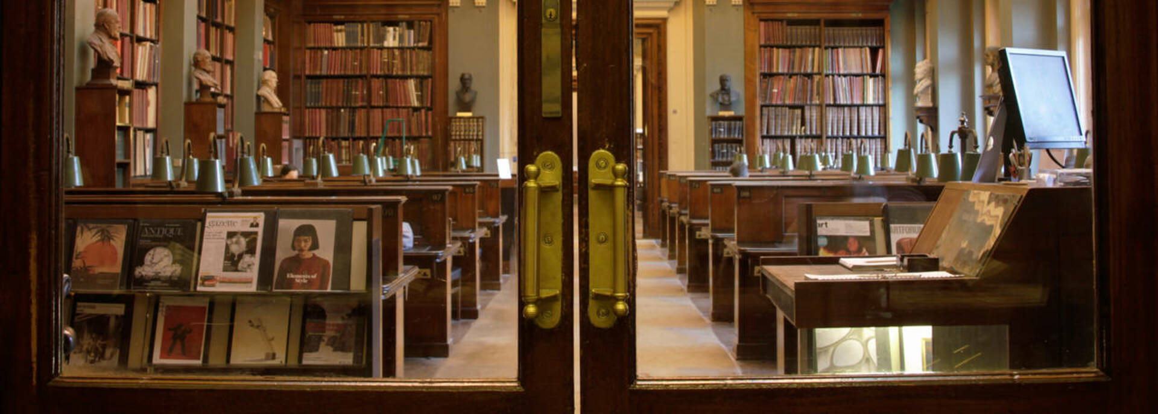
The National Art Library is situated in beautiful and historic reading rooms overlooking the John Madejski Garden at V&A South Kensington. It holds the UK’s most comprehensive public reference collection of literature on the fine and decorative arts, including books, journals, exhibition catalogues, auction house sales catalogues, comics, e-resources and much more.

- I consulted May Morris’s Day Book from 1892 to 1896, the only surviving accounts from Morris & Co’s embroidery department run by May Morris. This provides information about clients, bespoke commissions, stock items, sale prices, as well as a couple of letters addressed to Mrs Sparling; May became Mrs Sparling when she married Henry Halliday Sparling in 1890.
- I also consulted the Burlington Fine Arts 1905 exhibition catalogue of English embroidery executed prior to the middle of the 16th century. This provides an insight into collectors of the period and contains vivid illustrations of medieval chasubles from which May Morris clearly took design inspiration; she was a likely visitor to this exhibition.
- Both primary sources will inform the content of the second room of the exhibition, which will focus on Morris & Co’s embroidery department from 1885 to 1896.

Emery Walker’s House, Hammersmith, London
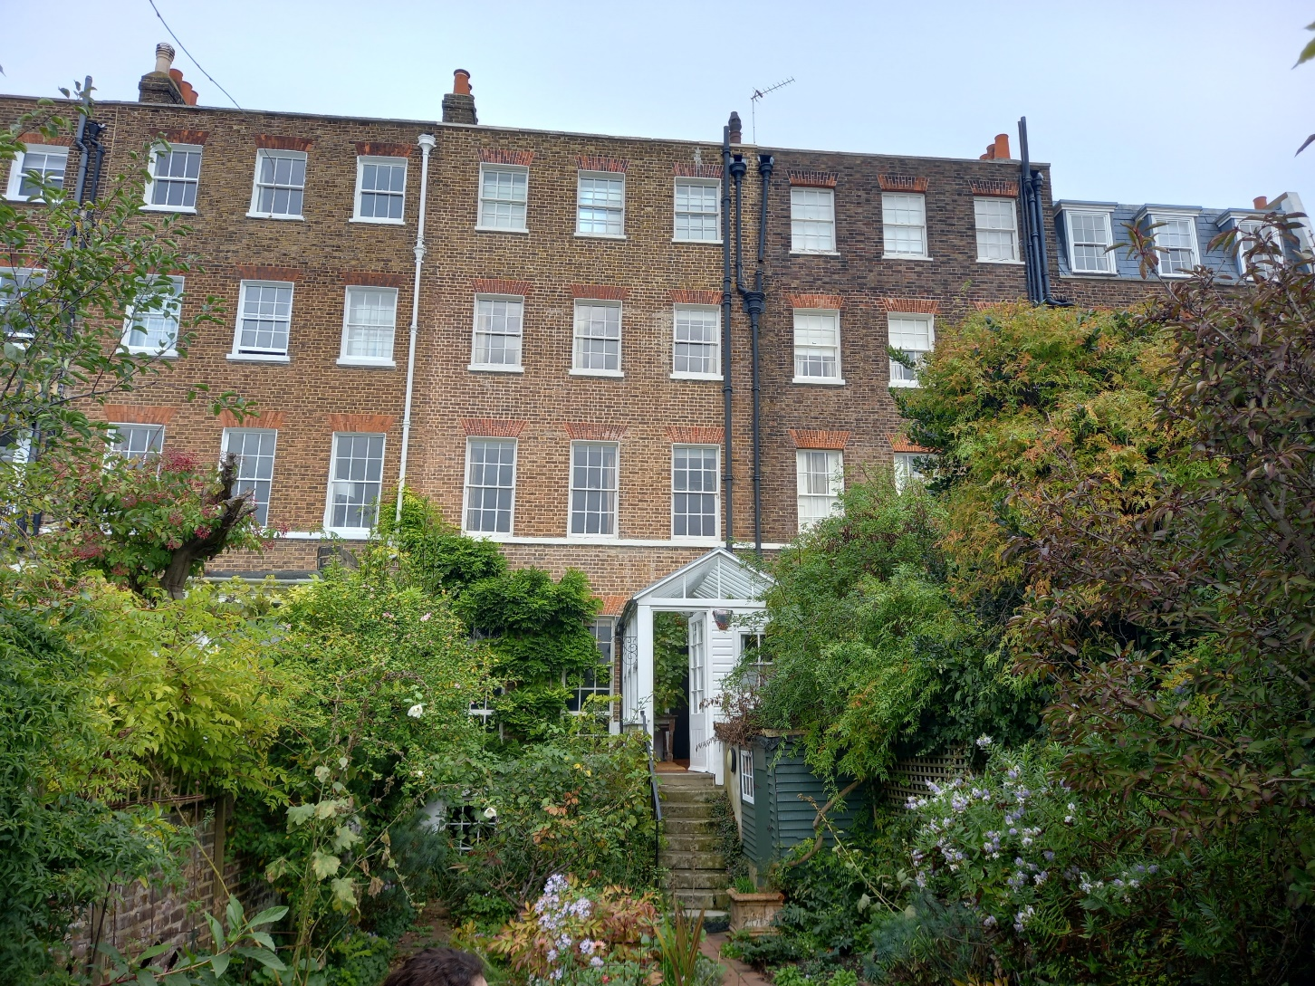
The tall, terraced house on the River Thames at 7 Hammersmith Terrace was home to printer, photographer, and typographer Emery Walker from 1903 until his death in 1933. Unlike many recreated historic houses, Emery Walker’s House remains largely untouched, offering a genuine look into a real Arts and Crafts home.
The interiors are a beautiful example of the Arts and Crafts movement’s principles. The walls are adorned with hand-printed Morris & Co wallpaper, with furniture designed by Philip Webb, alongside Middle Eastern rugs, and Chinese and Moroccan ceramics. Emery Walker and William Morris were good friends (as well as business partners) which is evident from some of the personal items associated with Morris and his family on display; these include a library chair, a lock of Morris’s hair and a pair of his spectacles, and an uncut woodblock from the Kelmscott Press which Morris and Walker founded.
The Emery Walker Trust is responsible for 7 Hammersmith Terrace.

- Visiting Emery Walker’s House was a rare opportunity to experience an authentic Arts and Crafts interior.
- Emery Walker is an important figure in the story of printing. He will feature in the third room of the exhibition which will consider May Morris as an editor of her father’s literary works.
- As a married woman, May lived at 8 Hammersmith Terrace. Exterior views of Hammersmith Terrace may feature in the exhibition graphics.

Kelmscott House, Hammersmith, London
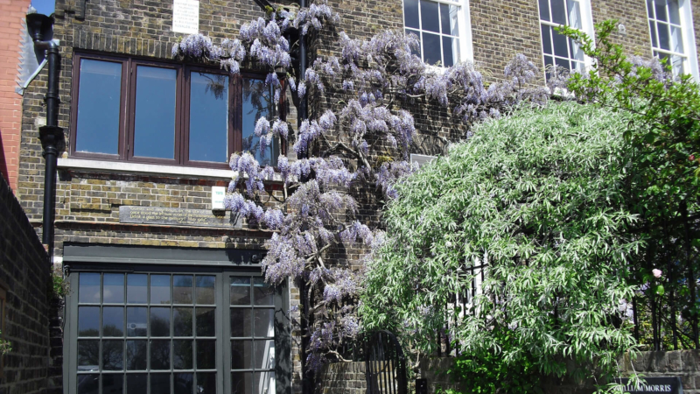
The William Morris Society was founded in 1955 to share knowledge of the life and works of William Morris (1834-96) among its members and the wider public. The Society and its small museum are based in the coach house and basement rooms of Kelmscott House, Hammersmith. This was Morris’s London home for the last 18 years of his life, and his daughter May’s childhood home.

- National Museums Liverpool is working in partnership with the William Morris Society to host this exhibition at the Lady Lever Art Gallery in 2026. Multiple loans from the Society will form the core of the exhibition.
- Visiting the William Morris Society was an opportunity to see highlights from the Helena Stephenson Collection; Helena Stephenson (1885-1972) was the final owner of Kelmscott House.
- The Morris & Co wallpaper and fabric books on display provide scope for learning about different patterns and colourways.
- The basement display with the Albion Press will inform the content of the third room of the exhibition, which will consider May Morris as an editor of her father’s literary works.
- Photographs showing the exterior, interior and garden of Kelmscott House may be used for graphics in the first room of the exhibition, which will focus on May’s childhood.

William Morris Gallery, Walthamstow, London
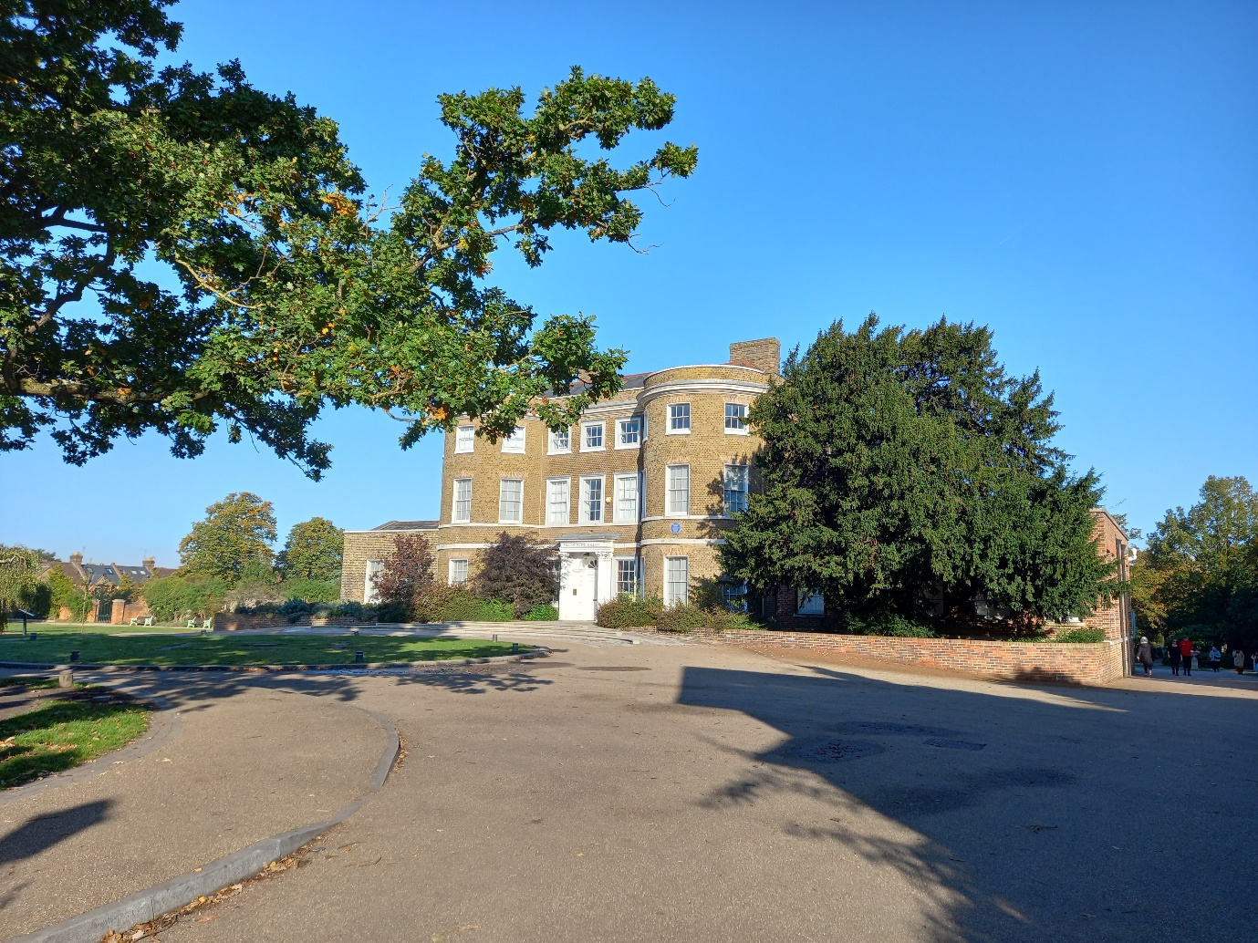
William Morris Gallery is the only public gallery devoted to the designer, craftsman and radical socialist William Morris (1834-96). Set in Lloyd Park, the gallery is housed in a Grade II listed Georgian building that was Morris’s family home from 1848 to 1856. It displays the world’s largest collection of his work, sharing the rich artistic and social legacy of one of Britain’s greatest designers.
Morris’s design company, Morris & Co, was awarded the Royal Warrant for its contributions to the coronation of King George V in 1911. The first plans to establish a gallery dedicated to Morris were drawn in 1914, and nearly four decades later Prime Minister Clement Attlee opened William Morris Gallery in 1950. Queen Mary (1867-1953), King George V’s widow, was one of the Gallery’s first visitors.
The Gallery also commemorates the achievements of artists Sir Frank Brangwyn and Arthur Mackmurdo. The former began his career as an apprentice draughtsman with Morris & Co in the 1880s. Both artists presented a large collection of art from the 19th and early 20th centuries to the Gallery, in memory of Morris.
Waltham Forest Council owns and manages the Gallery which underwent a major redevelopment in 2011-12.
- The seven galleries are themed to reflect different aspects of Morris’s life and work: Meet the Man, Starting Out, Morris & Co, The Workshop, The Shop, The Ideal Book, and Fighting for a Cause. All seven sections are rich in information (see Appendix) and will inform content for the three rooms of the exhibition.
- Images of The Workshop may influence the design of the second room of the exhibition, which will focus on Morris & Co’s embroidery department.
- Potential loans of objects may be requested from the William Morris Gallery for the exhibition.
- Consulting the May Morris archives at the William Morris Gallery was hugely beneficial, and excerpts from May’s childhood journal will certainly feature in the first room of the exhibition. There are also her notes and sketches of embroideries, as well as letters and mementoes.

Red House, Bexleyheath, Kent
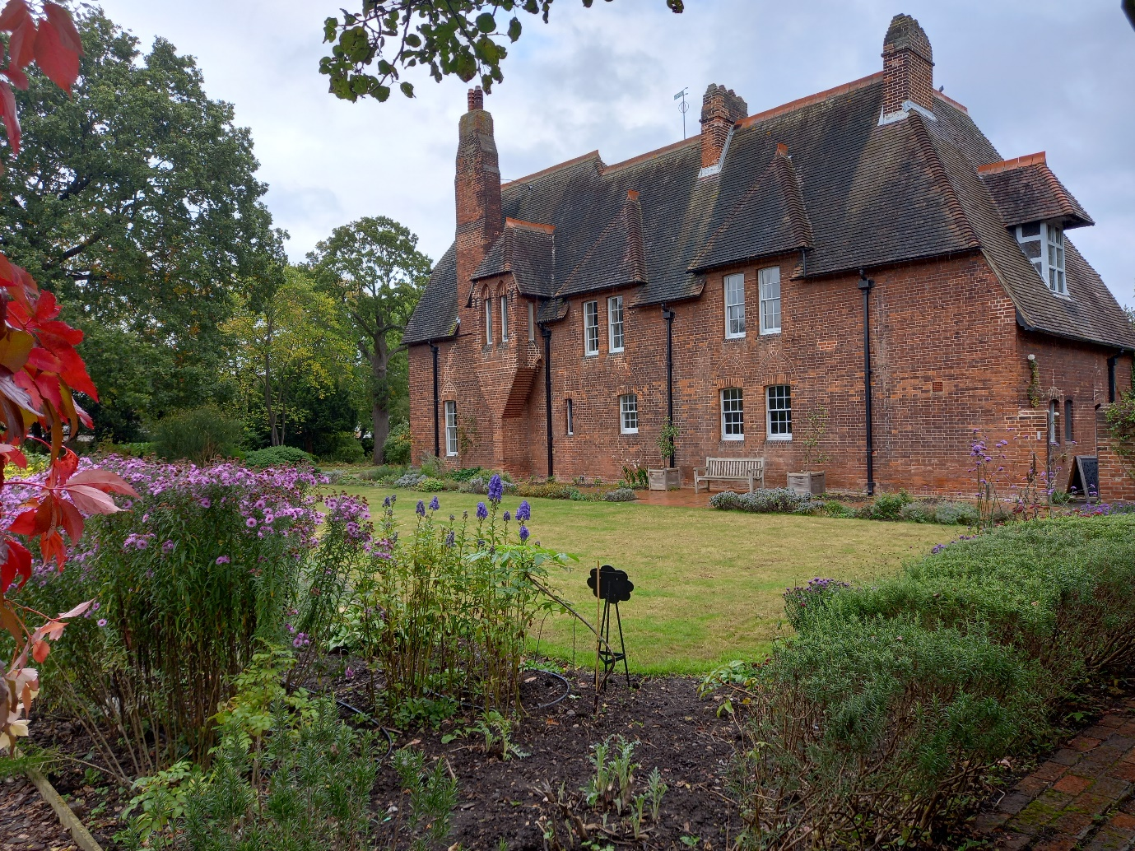
Red House is the only house designed, built, and lived in by William Morris (1834-96). Pioneer of the Arts and Crafts movement, Red House was the birthplace of this decorative style and a haven for the Pre-Raphaelite artists.
In 1859 newly married William Morris commissioned his friend, architect Philip Webb, to build him a house. Morris and Webb designed Red House without unnecessary decoration, instead choosing to champion utility of design which became a principle of the Arts and Crafts movement. When viewed from the outside, Red House is asymmetrical because no unnecessary windows or elevations were added. Each room within the house has the number of windows needed for its primary purpose. The master bedroom, for example, has one of the smallest windows; large windows were not considered necessary for a room used predominantly at nighttime.
The house was a family home, and a place where Morris and his circle of friends could live and work, according to the ideals and aspirations stemming from a shared love of medieval art and literature. Philip Webb designed furniture in the Gothic style which complemented the romantic medieval look of the house. Dante Gabriel Rossetti, Elizabeth Siddal and Edward Burne-Jones also contributed to mural paintings and furniture decoration. This communality and atmosphere of artistic experimentation and invention directly led to the founding of Morris, Marshall, Faulkner & Co (aka ‘The Firm’) in 1861.
Only four years later Morris was compelled, for business reasons, to move his family back to London. In 1866 he sold Red House as ‘…he could not bear to play landlord to the house he loved so well…’ (Georgiana Burne-Jones). Once described by Dante Gabriel Rossetti as ‘…more a poem than a house…’, Red House was the only home that Morris ever owned.
Today, the National Trust is responsible for Red House.
- A guided tour of Red House brought to life the story of Morris & Co and the playful friendships which grew there from a shared love of medievalism and creativity.
- Photographs showing the exterior, interior and garden of Red House may be used for graphics in the first room of the exhibition, which will focus on May’s childhood.

Kelmscott Manor, Oxfordshire
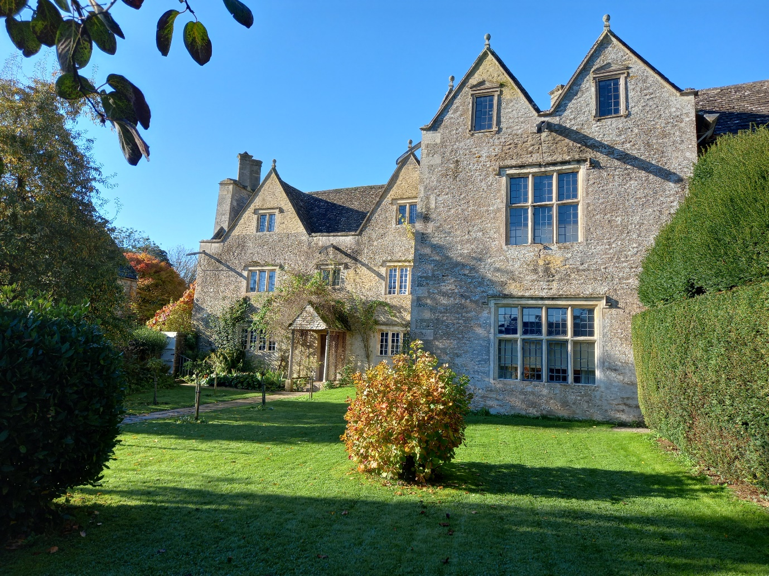
Kelmscott Manor is a rambling, limestone-built farmhouse that was the country home William Morris from 1871 until his death in 1896. It is an internationally important cluster of listed buildings, with a collection comprising furniture, pictures, textiles, and objects created by and associated with William Morris the designer, craftsman, pioneer socialist and a founding father of building conservation, his family and circle.
Morris and his friend Dante Gabriel Rossetti, a painter and poet, took a lease on the property in 1871, though Rossetti’s association with the Manor lasted only three years. Following William’s death in 1896, his widow Jane purchased the property and lived there with their daughters May and Jenny. May died in 1938, leaving it to Oxford University. In 1962 the estate passed to the Society of Antiquaries (as the residue legatee of May’s will) and now plays a vitally important part in meeting the Society’s charitable objective to share the care and understanding of the remains of the past with a wide audience.
For Morris, Kelmscott Manor was a source of emotional and artistic inspiration. He thought of it as ‘a heaven on earth’, and felt renewed by its beauty and quiet, once writing to a friend: ‘the ancient house had me in its arms again’. He claimed to love ‘the Earth through that small space of it’.
Today, the Society of Antiquaries is responsible for Kelmscott Manor.

- The interpretation panels at Kelmscott Manor (see Appendix) are rich in information about May’s lifestyle and much of this content will be shared in the Lady Lever Art Gallery’s exhibition.
- The various colours and patterns of the room interiors will inspire the design of the exhibition.
- To capture the essence of Kelmscott Manor, a soundscape with bird song and a flowing stream could be created for the first room of the exhibition.

Western Art Print Room, Ashmolean Museum, Oxford
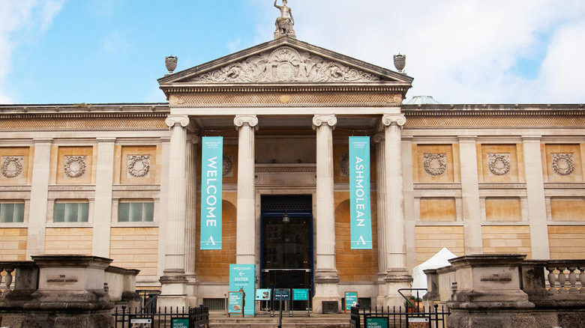
On 8 January 1941 Dr Karl T Parker, Keeper of the Department of Fine Art in the Ashmolean Museum, Oxford, received a note acknowledging receipt of his cheque for £12 in exchange for ‘miscellaneous material’ recently found at Kelmscott Manor, Oxfordshire, the former home of William Morris (1834-96) and his daughter May (1862-1938). Reportedly sent ‘by the occupier’ of Kelmscott, this material formed part of the estate of Mary Frances Vivian Lobb (1878-1939), May’s companion of over 20 years.
According to the Ashmolean’s Annual Report for 1941, these ‘residual drawings’ included a considerable number of ‘working designs by Miss May Moris’. They were to join the four large drawings by Dante Gabriel Rossetti (1828-82) already bequeathed to the museum by May, together with the Prioress’s Tale Wardrobe (1859), painted by Edward Burne-Jones (1833-98) as a wedding gift for William and Jane Morris. Two further Rossetti drawings had also been purchased by the museum at the Kelmscott auction sale of May’s effects.
The copious drawings, embroidery patterns, and black and white photographs discovered at Kelmscott Manor remained mostly uncatalogued until recent interest in May as a designer and embroiderer prompted further research.

Visiting the Western Art Print Room at the Ashmolean Museum to photograph May Morris’s pencil sketches and watercolours was a rare treat. Several works of art have been identified as potential loans for the exhibition.

From looking closely at the Ashmolean’s textile gallery, with its displays of medieval Islamic embroideries, Indian block-printed textiles, 17th-century embroideries, and examples of Opus Anglicanum, it is evident that May Morris sought design inspiration from a variety of sources.
Conclusion
I would sincerely like to thank the Worshipful Company of Upholders for giving me the opportunity to visit such a variety of museums, galleries, houses and archives pertaining to the Arts and Crafts movement. It has been an enrichening experience, and the knowledge gleaned will benefit the development of a forthcoming exhibition about May Morris at the Lady Lever Art Gallery, in terms of content, design and interpretation.

Fiona Slattery Clark
Curator of Decorative Art
National Museums Liverpool

15 January 2025
Appendix

William Morris Gallery

Gallery 1: Meet the Man
William Morris was a designer, craftsman, poet and social activist. He was born in Walthamstow in 1834 and lived in this house as a teenager. This room offers an introduction to his varied achievements.

The eldest son from a wealthy family, he had a conventional middle-class upbringing. But he shocked his family by choosing to become an artist instead of a clergyman. Together with a group of friends, he founded a hugely successful interior design business, Morris, Marshall, Faulkner & Co, later to become simply Morris & Co.

Morris wanted to transform the Victorian age. He thought beauty was a basic human need and wanted to bring art into everyday life. He hated the effects of Victorian industrialisation, which had led to overcrowded towns and cities, slum housing, epidemic disease and environmental pollution.

Morris also fought for social equality and a return to craftsmanship. He campaigned for the preservation of historic buildings and against the wasting of natural resources. When he died in 1896, his doctor said: ‘the cause was simply being William Morris and having done more work than most ten men’.

Designer
“Don’t copy any style at all, but make your own.” (William Morris)

William Morris’s pattern designs have endured for over a century and are still reproduced today. Many of his original drawings have survived and provide an insight into his working technique. Morris drew, revised and finally coloured a pattern on a single sheet of paper, believing that a harmonious piece of work should be done in one attempt.

Colour
One of Morris’s talents as an artist was his eye for colour. He loved the rich jewel-like shades in medieval art. Attention to colour pervaded all his craft activities. He spent years experimenting with natural vegetable dyes for his textiles.

Manufacturer
“The true secret of happiness lies in the taking a genuine interest in all the details of daily life.” (William Morris)

The poor design and quality of many Victorian machine-made goods angered Morris. He wanted to improve manufacturing standards in Britain. To achieve this, he revived many traditional techniques in his own workshops.

The art of hand-knotting carpets had nearly been forgotten in Britain. Inspired by the example of hand-knotted Persian and Turkish rugs, Morris set up his own loom. After teaching himself the technique, he passed it on to his employees.

Retailer
“To apply art to useful wares…is not a frivolity, but a part of the serious business of life.”
(William Morris)

Morris established a successful interior design business selling household furnishings. He built his business on the promise of quality. Promotional materials emphasised artist-led design, fine materials and traditional craft techniques.

Gallery 2: Starting Out
“With the arrogance of youth, I determined to do no less than to transform the world with beauty.” (William Morris)

At university Morris met his closest friend and collaborator, Edward Burne-Jones. Both defied their families by rejecting secure careers in the Church and dedicating their lives to art.

Their decision was strongly influenced by the writings of John Ruskin. Ruskin decried the moral bankruptcy of Victorian art and society, urging a return to the values of the medieval past. His views immediately resonated with Morris’s rebellious nature and instinctive appreciation of the past.

Through Ruskin, Morris and Burne-Jones discovered the controversial young painters known as the Pre-Raphaelites. They admired the group’s bold defiance of the art establishment and soon fell in with one of the instigators: the charismatic painter and poet Dante Gabriel Rossetti.

After leaving university, Morris tried to find his creative outlet. He wrote poetry, studied architecture and struggled to master oil painting. He discovered a talent for interior design in the course of decorating his own home. Together with friends, he found a decorating business offering an alternative to the goods of industrial Britain.

Finding inspiration
Morris often felt he’d been born in the wrong century. As a young artist he looked to the past for inspiration. He visited Gothic cathedrals in England and France, admiring the skill and craftsmanship of medieval stonemasons, sculptors and stained-glass artists. He hoped to learn from their example and bring the same creativity and individuality to his own work.

Launching a business
“All the minor arts were in a state of complete degradation, and with the conceited courage of a young man I set myself to reforming all that.” (William Morris)

The experience of decorating Red House launched Morris’s career as a designer. In 1861 he founded an interior decorating business with six partners, including Burne-Jones, Webb and Rossetti.

Morris, Marshall, Faulkner & Co started out with limited experience and very little capital. With a start up loan from Morris’s mother, ‘The Firm’, as it became known, offered all types of decoration, from wall paintings to stained glass and furniture. As part of their ‘crusade against the age’ the partners decided that their products would be made by hand wherever possible.

The business began as a small, family-based operation. The wives and sisters of the partners helped out, especially with tile painting and embroidery. Morris had most at stake in the new business. The other partners were also pursuing separate careers – as painters and architects – but for Morris the Firm became his main source of income.
Mixed reactions
At their first trade exhibition in 1862 the Firm won two medals and attracted important new clients. But some reviewers were less impressed and mocked their medieval-style furnishings for being old-fashioned.

The Building News reported: ‘The most thoroughly medieval of any in the Court, they are consequently the most useless…their hangings, their music stand, their sofa, their chests, would all suit a family which might suddenly be awakened after a sleep of four centuries…they are no more adapted to the wants of living men, than medieval armour would be to modern warfare’.

Gallery 3: Morris & Co
“I have never been in any rich man’s house which would not have looked the better for having a bonfire made…of nine-tenths of all that it held.” (William Morris)

Morris and his friends disliked the clutter of many wealthy Victorian homes. Their interior design company promoted well-made, understated design. It took time to win over the public and for many years only the most avant-garde bought from the Firm.

Morris & Co faced strong competition, and quality alone could not guarantee commercial success. Morris learnt to be a shrewd businessman. In 1875 he bought out the other partners, renaming the business Morris & Co. He expanded the range of products and opened a shop on fashionable Oxford Street. Publicity helped to create a strong brand identity based on quality materials, artist-led design and high standards of craftsmanship. By the end of the century, Morris & Co had become a byword for good taste.

Making a name
In the 1860s the Firm made two major breakthroughs. First, they won a commission to decorate the Armoury and Tapestry rooms at St James’s Palace. Arranged through Rossetti, this was a spectacular coup: the young, little-known design business triumphed over favoured royal decorators.

The Firm was also invited to decorate one of the refreshment rooms at the new South Kensington Museum (now the Victoria & Albert Museum). This was a terrific endorsement from a museum with a mission to raise standards of British design. The ‘Green Dining Room’ was a fashionable meeting place for artists and is still in use today.

Off the shelf
Only the very rich could afford bespoke commissions and a visit from Morris in person. To reach a wider market, the Firm developed a range of more affordable products that could be kept in stock. This move was well timed to coincide with a rising interest in interior design among the middle classes. Fashionable decorating manuals often recommended Morris & Co’s embroidery kits, wallpapers, chintzes and tiles.

Morris regretted that his high quality, handmade products were beyond the means of ordinary working people. His dissatisfaction contributed to his growing political radicalism.

Painted tiles
Decorative tiles provided the Firm with a steady stream of income. Wealthy customers could order a specially designed tile panel, but those on a smaller budget could buy batches of stock tiles. The Victorians often used tiles to decorate fireplaces.

Rounton Grange, Yorkshire (1870s)
Many of Morris & Co’s clients were rich industrialists. Often keen collectors of Pre-Raphaelite paintings, they showed the same rebellious taste in their interiors.

Chemist and ironmonger Sir Isaac Lowthian Bell appointed Philip Webb to build Rounton Grange and commissioned the Firm to decorate it. Morris supervised the scheme personally. On one occasion he lost his temper, complaining that ‘I spend my life ministering to the swinish luxury of the rich’. Fortunately, Lowthian Bell took the outburst in good humour. His children continued to buy from the Firm for many years.

Rich patrons enabled the Firm to take on really ambitious projects. Burne-Jones and Morris designed their largest embroidered frieze, over 20 metres long, for Rounton Grange. The embroidery is now in the William Morris Gallery’s collection, but it is too fragile to be displayed permanently.

Selling to the world
Morris & Co had important clients in Europe, America, Australia and Canada. This was partly due to the success of the Oxford Street shop, where wealthy tourists could view samples and place large orders. London was the heart of a trading empire, and goods could be shipped all over the world.

Although he complained about ‘the almost prohibitory tariffs’, Morris actively tried to expand his business internationally. He appointed agents to sell his work in New York and Boston and sent his business manager, George Wardle, to visit potential customers.

The Firm also advertised its products with large stands at international trade fairs: Philadelphia in 1876, Boston in 1883, Paris in 1900. Fairs generated sales and helped to raise the company’s profile abroad.

Morris & Co in the twentieth century
The Firm continued to trade after Morris’s death in 1896. John Henry Dearle, Morris’s trusted assistant, became art director. There were moments of success, including the opening of a fashionable new showroom on George Street, Hanover Square, in 1917. Morris and Burne-Jones’s designs continued to be re-used, but without the artistic leadership to innovate and adapt to changing tastes the business foundered. The company went into liquidation in 1940.

The printed fabrics and wallpapers, however, have been printed almost continuously since Morris’s death. Colours and techniques have been adapted to suit modern tastes but demand for the patterns has never disappeared.

Gallery 4: Workshop
“That thing which I understand by real art is the expression by man of his pleasure in labour.”
(William Morris)

Morris was determined to raise the standard of manufactured goods. He admired traditional crafts from around the world and introduced many of the same techniques in his own workshops. In this gallery you can explore how Morris & Co products were made.

In 1881 Morris moved his workshops out of London to Merton Abbey in Surrey. This rural location provided the space he needed to expand the range of products manufactured in-house. The river Wandle ran through the site providing a supply of fresh running water for dyeing and printing textiles.

He wanted to offer a healthy and pleasant working environment for his employees. The ramshackle workshops had nothing in common with industrial factories, which Morris described as ‘nightmare buildings’ and ‘temples of overcrowding and overwork’.

Merton Abbey
The ramshackle workshops were built in the eighteenth century by Huguenot silk-weavers. Morris preserved the existing building, making only minor modifications.

The operation was small-scale compared with many factories, with around 100 employees in the mid-1880s. Workers enjoyed clean air and rural surroundings. Morris planted trees and flowers and hired out plots in the kitchen gardens to workmen. The workshops had lots of natural light and views over the river Wandle.

Despite these benefits, the processes Morris revived were often repetitive and time-consuming. Morris’s ideal was that everyone should experience pleasure through labour. But in reality his employees had limited opportunities to explore their own creativity, or even vary their activity.

Silks from Merton Abbey
As well as dyeing cloth, Morris & Co dyed the wool and silk yarns used for embroidery and woven textiles.

Herball or Generall Historie of Plants
Herbals illustrate different plants and their uses. Morris had a copy of one as a child. The roots of the madder plant produce a red dye.

Natural dyes
“Then came one of the most wonderful and most useless of the inventions of modern Chemistry, that of dyes made from coal-tar, producing a series of hideous colours, crude, livid and cheap, which every person of taste loathes.” (William Morris)

Synthetic chemical dyes were relatively cheap and easy to use and offered a whole new range of colours. But Morris thought the bright, harsh tones lacked character and was determined to revive the art of using natural dyes.

Morris enlisted the help of Thomas Wardle, a chemist and prominent silk-dyer based in Leek, Staffordshire. Both men admired naturally dyed Indian textiles. It took nearly ten years of experimentation to achieve the same high-quality results.

Indigo
Morris disliked the bright blues produced by synthetic dyes and spent years experimenting with natural indigo, a plant extract. Indigo can yield an exceptionally rich range of blues, but it requires experienced handling.

The indigo vats at Merton Abbey needed constant care and attention. A good sense of smell was vital to determine when the vat was ready to receive the cloth. Misjudged timing or ingredients produced a streaky not a solid blue.

Textile printing
At Merton Abbey craftsmen printed Morris & Co textiles by hand using carved woodblocks.
Each colour had to be printed with different sets of blocks.

By the mid-nineteenth century, leading commercial manufacturers had switched to engraved roller printers. One roller-printing machine could print as much cloth as 20 hand-block printers. Yet Morris believed that the ancient, block-printing process created a better-quality finish, reintroducing skill and craftsmanship to textile manufacture.

Indian block-printed textiles
The ancient craft of block-printing textiles by hand is still practised in parts of India. The colours and traditional patterns are similar to those Morris admired in the nineteenth century.

Designing from nature
As a child, growing up in the Essex countryside, Morris could name many different plants, flowers and birds. His sensitivity to the landscape and keen observation of nature continually informed his work.

He advised would-be pattern designers to abstract from nature rather than copying literally. Patterns should have order and structure, and lines should be strong and crisp, not weak or flabby.

Birds and animals
Morris loved bird watching and carefully studied the behaviour and song of different species in the wild. Yet in his repeat patterns he avoided the realistic depiction of birds and animals. He believed their form should be abstracted to give structure to the pattern. With their wings poised for flight or their beaks about to pluck the fruit, they remind us of the outdoors without distracting us with too much detail.

Rivers
Morris named a group of his most sophisticated patterns after tributaries of the river Thames. The patterns share a sense of movement, created by the meandering diagonal stems. They hint at natural growth: Morris said, ‘even where a line ends it should look as if it had plenty of capacity for more growth’. Morris delighted in travelling up the Thames with his friends from his London home in Hammersmith to his country retreat, Kelmscott Manor in Gloucestershire.

Designing textiles
Many of Morris’s original hand-drawn designs for textiles have survived. They were never intended for public display and often show signs of wear and tear – stains and creases from everyday use in the workshop.

For repeating patterns, it was only necessary to colour in a small section to show the weavers how to proceed.

Protecting designs
A design could be protected by registering it with the Board of Trade. Morris & Co did this selectively, concentrating on patterns that represented new ideas or techniques, especially those produced with the indigo ‘discharge’ method.

A diamond-shaped mark on an object indicated the maker’s exclusive right to that design for a fixed period of time. The Design Registers survive at the National Archives in Kew.

Dating Morris & Co printed textiles
Identification marks were often printed along the finished edge of the fabric (known as the selvedge). These marks changed over time so can help to give an approximate date range.

Some fabrics are printed ‘REGD Morris & Company’ on a wavy line. This form was in use between 1917 and 1940.

Production costs
The cost of different fabrics varied greatly depending on the complexity of the design and the number of colours used. Borage, designed for lining curtains but also used as a dress fabric, could be printed using only one block. At the other end of the scale, Cray was the most complex and expensive block-printed fabric Morris ever designed. Thirty-four different woodblocks were required to print a single length.

Carpet knotters at work at Merton Abbey
Morris thought women’s small fingers were best suited to the intricate work of knotting carpets. Each woman could produce around 5 centimetres of carpet a day.

‘Above and behind [the women] rows of bobbins of many coloured worsteds, stuck on pegs, shower down threads of beautiful colours, which are caught by the deft fingers passed through strong threads…tied in a knot, slipped down in their place, snipped even with the rest of the carpet, all in a second of time.’ (The Spectator magazine, 1883)

Kidderminster carpets
Morris’s Kidderminster carpets were made by the Heckmondwicke Manufacturing Company in Yorkshire. The finished design had to be transferred to point paper to prepare it for the loom. Dissatisfied with the Heckmondwicke’s initial attempts, Morris did the work himself, later training his own men.

Persian carpets
London was the centre of a thriving import trade in Persian carpets during the Victorian period. Morris was an enthusiastic collector and a fine seventeenth-century ‘vase carpet’ hung in his dining room at Kelmscott House, Hammersmith. Such was his expertise that the Victoria and Albert Museum sought his advice when buying Middle Eastern textiles for their collection.

Stained glass
Like other stained-glass makers of the day, Morris used medieval techniques. Craftsmen cut pieces of coloured glass to size, then painted on detail. They added the leading last.

The Firm never made its own glass, but obtained this from James Powell & Sons. Morris & Co excelled in design and use of colour, and Morris selected the glass for most of the windows himself.

Gallery 5: The Shop
“It is only in our Show Room, 449 Oxford Street, that our goods can be seen together…and so give a true idea of the decoration that we recommend.” (Morris & Co circular, 1882)

In 1877 the Firm opened a new shop on Oxford Street in the heart of London’s fashionable West End. Furniture, wallpapers and textiles were arranged in attractive room settings to inspire customers and to promote the ‘house style’.

Morris told a friend he would rather have had ‘a shed with half a dozen looms in it’ but the central location offered great potential to expand the business. Conveniently close to its main competitors, including Liberty’s on Regent Street, Morris & Co had a wide shopfront in which to display its wares.

In the early days of the Firm, Morris had often served customers himself. One client remembered him coming ‘from above with his hair on end and in a nonchalant way he began to show me one or two of his curios’. On Oxford Street, professional shop assistants gave advice and took orders.

Oxford Street showroom
“Mr Morris chose a prime location for his West End premises. Just a moment’s walk from the fashionable shops on Bond Street, it couldn’t be more convenient. The first-floor windows, where the light streams in, are used to display stained glass.”

Interior of the George Street showroom
The shop stayed open for business during the First World War despite many of the staff enlisting. The furniture workshops were converted into a propeller factory, but the shop survived. In 1917 it moved from Oxford Street to an equally fashionable address in George Street, Hanover Square.

Choosing a pattern
“Why not have a seat and browse through some of our latest collections? It’s important to take your time when choosing a pattern for your room. Ask yourself if you could live with this day-to-day; it is restful on the eye?

If you are looking for an exact imitation of nature, you will be disappointed. As Mr Morris says, ‘you can’t bring a whole countryside, or a whole field into your room’. A good pattern will gently remind you of the outside world and feed your imagination.”

Quality of manufacture
“It has come to our attention in recent months that, owing to their desirability, some of our products and designs have been unlawfully copied by our competitors. Whilst their prices may be slightly lower, do not be fooled. In all cases the quality of manufacture is far inferior.”

Swatch books
“Reliable clients may borrow these swatch books for leisurely perusal in the comfort of their own home.

Fabrics
The printed cottons are most suitable for upholstering furniture. Look, for example, at the splendid effect of the Lodden design on the nearby armchair. We strongly advise against choosing a woven fabric for this purpose; the mixture of silk and wool does not stand up well to being sat upon. Far better to opt for a durable cotton.

Wallpapers
Mr Morris would recommend that you limit yourself to just one, or at the most two, wallpapers per room. As he says, ‘a room papered all over would be like a box to live in’. However, if you do desire a ceiling paper, we have some simpler, more restrained designs to choose from.”

Ceramics
“Wherever possible, we try and arrange the showroom much as you might your own home. We find this helps clients to visualise the overall effect of a Morris & Co interior.
Here, we have a choice display of ceramics by William De Morgan and the Martin Brothers, complemented by metalwork from the Century Guild. The ruby red lustre on the vases is in perfect sympathy with the surroundings. The brass charger, with its pomegranate motifs, helps to reflect light around the room.”
Music cabinet
“Painted furniture has been one of the Firm’s specialities since its foundation. These unique items are only available by special commission. The potter William De Morgan painted the cabinet doors. The design was specially tailored to the client’s musical tastes – just look at Hermes playing the lyre, or Pan teaching Dionysus to play the pipes.”

Oak settle
“The original version of this settle was made for Mr Morris’s own house. Designed by his friend, the celebrated architect Mr Philip Webb, it is now available with plain oak panels or embossed leather paper.

Of course, elaborate gilded plasterwork, such as the magnificent putti an fruit trees on this example, can be specially commissioned at an extra cost. The seat is upholstered in deep crimson Morris & Co velvet. And do not be concerned about comfort – you can order a matching back cushion for a small additional fee.”

Embroidered wall hanging
“This hanging is not for sale and is here temporarily to show you just what can be achieved with the art of hand embroidery. It belongs to one of our regular clients, Mrs Battye, who executed all the stitch work herself. She often comes in to commission designs or stock up on our naturally-dyed silks.

Of course, we employ a number of fine needlewomen. They are more than capable of executing a work like this, but some of our clients enjoy the challenge of doing the stitching themselves.”

Gallery 6: The Ideal Book
“Ever since I can remember, I was a great devourer of books.” (William Morris)

Morris’s lifelong passion for books and storytelling fed into every aspect of his art. It stood at the heart of his friendship with Burne-Jones. Their shared love for myth and legend is immediately apparent in their decorative art.

At university Morris discovered his ability to soak up a story and make it his own. His poetic re-imagining of tales of the past made him famous. Despite his many other achievements, the Victorians knew Morris best as a poet and writer.

In the last years of his life Morris turned his attention to making books. Inspired by the medieval manuscripts he collected and frustrated with the poor standards of Victorian book design, Morris set up his own private printing company, known as the Kelmscott Press. He aimed to create books with ‘a definite claim to beauty’, designed to the highest standards and made with the best available materials.

The Earthly Paradise
“We take Morris’s poem into the woods with us and read it aloud, greedily, looking to see how much more there is in store for us. If ever you have an idle afternoon, bestow it on The Earthly Paradise.” (George Eliot)

In 1865 Morris started writing the poem that would make him famous. The Earthly Paradise was an instant bestseller. The poem tells the tale of a group of Nordic wanderers who set out to look for paradise. After many years they arrive on an island inhabited by descendants of the ancient Greeks. Once a month, the two groups meet and tell each other a story.

Morris us this structure to retell 24 of his favourite stories in verse, two for each month of the year. It was an ambitious project, especially for someone running a business at the same time. Morris wrote his poems in his spare time with remarkable speed, but freely admitted it was hard work: ‘That talk of inspiration is sheer nonsense…It’s a mere matter of craftsmanship’.

Iceland
Morris was not an adventurous traveller, with one notable exception. In the early 1870s he visited Iceland, drawn by his fascination with the ancient sagas.

The desolate, unpolluted landscape appealed to him. Morris and his companions set out on sturdy Icelandic ponies, crossing lava fields, rivers and icy mountains. It was physically demanding but he felt at home amongst the Icelandic people and respected their simple, frugal lifestyle: ‘the most grinding poverty is a trifling evil with the inequality of classes’.

The sagas were not his only reason for travelling to Iceland. His wife Jane had begun an affair with his friend and fellow artist, Rossetti. Iceland was a way to escape this double betrayal. Before he left, Morris took up the tenancy of Kelmscott Manor, a farmhouse on the edge of the Cotswolds. He left Jane and the children there with Rossetti.

Pioneers
The reform of Victorian printing was on the cards in the late nineteenth century. Artists and academics had started to debate the merits of type, materials and page layouts. The Century Guild, a collective of young artists grouped around A H Mackmurdo, published a magazine which anticipated many of Morris’s notions of the well-designed page.

A little typographical adventure
‘I began printing books with the hope of producing some which would have a definite claim to beauty, while at the same time they should be easy to read…’ (A Note by William Morris on his Aims in Founding the Kelmscott Press, Kelmscott Press, 1898)

The Kelmscott Press was William Morris’s last great stand against the industrial age. In 1888 he attended an illustrated lecture on the history of typography and decided there and then to start designing his own type.

It was a logical next step. Morris had been interested in books as objects for decades. He collected illuminated manuscripts and early printed books. In the 1860s he had tried, but failed, to print illustrated editions of his poems. The art of calligraphy and illumination occupied much of his spare time in the 1870s.

The Kelmscott Press was in operation between 1891 and 1898. During its short life it produced 52 titles which had a lasting influence on book design.

Integrated design
Morris argued that the typeface, illustration and page decoration of a book should complement each other. To this end, he designed his own type.

Golden type
This was Morris’s first type design, inspired by the work of a medieval printer named Nicolas Jenson. Morris wanted to do away with the thin, greyish letters used in most Victorian books.

Not everyone agreed it was an improvement. Stanley Morrison, a famous typographer, thought it was ‘positively foul’.

Chaucer type
This is a reduced version of the Troy type, designed for the Kelmscott Chaucer.

Fellowship
Morris surrounded himself with talented people at the Kelmscott Press. Emery Walker was an experienced and knowledgeable printer. He became Morris’s unofficial partner and advised on the technical aspects of printing.

Personal favourites
Which books did Morris decide to print at the Kelmscott Press? Some titles were chosen for sentimental reasons. Sidonia the Sorceress was an erotic novel about witchcraft and a great favourite of the pre-Raphaelites. But it didn’t sell well and, after Morris’s death, Jane donated the remaining stock to public libraries.

A failed project
Some titles were too obscure even for Morris’s loyal customers. So few advance orders were received for the proposed publication of Vitas Patrum (‘Lives of the Fathers’ – a book about early Christian hermits) that the project had to be abandoned.

A masterpiece
The Works of Geoffrey Chaucer was the most ambitious and richly-ornamented book the Kelmscott Press ever published. It took four years to make; Morris lived just long enough to see the book completed.

Commercial choices
The Poems of William Shakespeare was probably the most popular volume ever issued by the Press.

Writer
The bulk of the titles printed at the Press were Morris’s own works.

Choosing the illustrations
After a lifetime of collaborating with Burne-Jones, Morris found it hard to communicate his vision to anyone else. The Birmingham artist Arthur Gaskin was bitterly disappointed when, after much reworking, Morris eventually rejected his designs for The Well at the World’s End.

Ornament
Morris designed all of the Kelmscott Press borders and initials. First, he sketched faintly in pencil and then he applied Indian ink with a brush, making corrections with Chinese white paint.

Selecting the ink
Morris used black, blue and red ink for the Kelmscott Press books. The black ink was the most important. Instead of the greyish looking text of machine-printed books, Morris wanted strong, intensely black letters.

After some experiment he decided on a black ink from Germany. But the pressmen complained; the thick ink was very difficult to use. When they threatened to strike, Morris threatened to close the Press, and so the Pressmen gave way. Emery Walker remembered they got their own back; for a while ‘the number of sheets turned out per day was extraordinarily small’.

Designing the binding
All Kelmscott Press books were issued with temporary bindings. The Chaucer was no different, customers could opt for a special binding designed by Morris.

‘I am not a jobbing printer’
Morris disliked printing leaflets, although he made exceptions for personal friends. The Ancoats Brotherhood was a socialist workers’ organisation in Manchester. After lecturing there once, Morris often attended their meetings and produced a leaflet for them.

Book collector
Particularly in his later years, Morris was wealthy enough to collect beautiful books. The medieval manuscripts and early printed books in his library inspired the design of Kelmscott Press books.

The Kelmscott Press legacy
The nature of Morris’s contribution to modern book design has always sparked debate. But it is undeniable that the Kelmscott Press helped to revive interest in fine printing in Europe and America.

The Eragny Press books are one example of Morris’s influence. The Press was founded by the Impressionist painter Lucien Pissarro and his wife Esther in 1894.

Gallery 7: Fighting for a Cause
“How can I ask working men passing up and down these hideous streets day to day to care about beauty?” (William Morris)

When he was nearly 50 William Morris, a successful businessman, took an extraordinary step: he became a Socialist. For the rest of his life, he campaigned to end the system of privilege which allowed the property-owning classes to profit from the labour of the rest of society. Concerned that gradual reform would only mask society’s problems and delay change, he wanted revolution.

What inspired this commitment? Morris was aware that it was only his ‘good luck of being born respectable and rich’ that allowed him to live away from ‘the drink-steeped liquor shops and foul and degraded lodgings’. He condemned the excess and wastefulness, which forced workers to endure dull repetitive labour.

Morris’s concern with the destructive effects of industrialisation extended beyond the workplace. Hi campaign on a range of environmental issues, including the protection of historic buildings, continue to resonate today.

Environmentalist
Morris called for action to protect the countryside. He personally campaigned to stop the pollution of the Thames and the destruction of trees in Epping Forest. In his poetry and art, he equates beauty with nature.

Spreading the word
Commonweal was a socialist newspaper designed to win new recruits to the cause. It was edited and financed by Morris, who helped to sell copies on the streets.

Unjust war
In 1877 Morris called on the ‘Working-men of England’ to resist the government’s attempts to drag the country into a Russian-Turkish war. The ruling classes, he claimed, were led only by desire for profit.

Wake, London Lads!
Morris wrote this song to win popular support for the protest against the war. It was the first time he used his skills as a poet to serve a political purpose.

Educate! Agitate! Organise!
Socialism in the 1880s was never a mass movement. Supporters numbered in the hundreds, no thousands. Cheap pamphlets were handed out in the streets to help spread the message.

An early manifesto (Socialism made plain being the Social and Political Manifesto of The Democratic Federation) calls for an eight-hour working day, affordable hygienic housing, free school meals and the nationalisation of banks and railways.

Crime and punishment
Morris accused the British legal system of hypocrisy. Working-class people were far more likely to be arrested and imprisoned than wealthier ‘respectable’ citizens.

Morris himself was involved in several confrontations with the police. Ironically, they treated him more leniently than other demonstrators because he was a public figure.

Paris Commune – ‘The Greatest Tragedy of Modern Times’

For a few months in 1871, the workers of Paris seized control of the city. This brief experiment in self-government was violently suppressed by the authorities. Thousands were executed or fled abroad.

Morris hoped that the example of the Commune, however short-lived, would inspire the workers of Britain to rise up and seize power for themselves.

Who was John Ball?
John Ball was a radical priest during the Peasants’ Revolt of 1381. In a famous speech he claimed all men were created equal: When Adam delved and Eve span, who was then the gentleman?’

Morris wrote a story about him which he read aloud at socialist gatherings. It contains his famous words ‘fellowship is life, and lack of fellowship is death’.

Bloody Sunday
London’s poor were hard hit by recession and unemployment in the 1880s. Many took to the streets to demonstrate. The government was nervous and banned public meetings.

The situation came to a climax on 13 November 1887. Morris was among the protesters who marched towards Trafalgar Square. Before the crowds could congregate, the police and the army used force to disperse them.

Alfred Linnell
A week after ‘Bloody Sunday’ the protesters regrouped. Alfred Linnell, a law clerk, got caught up in the demonstration and was fatally wounded by police. He became a martyr to the cause and thousands attended his funeral.

Morris, one of the pallbearers, wrote a song in Linnell’s honour that was sold to the crowds to raise money for his orphaned children.

Useful work versus useless toil
Morris believed everyone had the right to a satisfying work life, balanced with time for leisure and rest.

He hoped for a sustainable future, without excessive consumerism. People would only produce what was absolutely necessary to live comfortable and creative lives.

Walter Crane
The artist Walter Crane converted to socialism in the 1880s. Almost single-handedly, he created a new visual language to promote socialist ideals.

His designs appeared on posters, membership cards, leaflets and banners. Like Morris, he believed that socialism could reform the arts as well as society.

Eleanor Marx
Eleanor, the youngest daughter of Karl Marx, was a committed activist who helped Morris to found the Socialist League. She wrote for Commonweal, supported striking women workers and organised international socialist conferences, though a painful private life eventually contributed to her suicide aged 43.

A Factory As It Might Be, reprinted about 1907
In Morris’s ideal society, factories would be pleasant places of education, where people make beautiful and useful things.

Under An Elm Tree; Or Thoughts In The Countryside
Morris wasn’t just concerned about urban deprivation. He argued that country life needed to be revitalised for ordinary people, and the landscape claimed back from landowners and developers.

Monopoly, Or How Labour Is Robbed, 1890
Morris claims the wealthy are like parasites who exploit the workers so they can lead comfortable lives.

The Society for the Protection of Ancient Buildings (SPAB)
“I wish for…an association…to keep a watch on old monuments, to protest against all ‘restoration’ that means more than keeping out wind and weather.” (William Morris, March 1877)

William and Philip Webb founded this society in 1877 to protect historic buildings from insensitive restoration or demolition. At the time, there were no laws to restrict what private owners could do to their property. Morris was one of the first to argue that everyone had a stake in ancient buildings, including future generations.

The Society promoted careful repair and regular maintenance as an alternative to intrusive restoration. Morris wrote forceful letters to the press and spoke up for the ‘beauty of the weathered and time-worn surface of an ancient building’. Far from discouraging architectural originality, he urged modern architects to avoid pastiche and create something new and appropriate to the present. SPAB still exists today.

Speaking out
In 1885 Morris spoke at a public meeting against the threatened demolition of nine medieval churches in York. The plans were abandoned and the churches saved.

Old Clergy House, Alfriston, Sussex
The Society campaigned to save all types of buildings – from great cathedrals to barns and domestic dwellings. When the newly-established National Trust acquired its first property in Alfriston in 1896, it adopted SPAB’s approach of gentle repair.

The Cyprus appeal
In the early twentieth century the Society had some success protecting medieval crusader buildings in Cyprus. In 1907 it published an appeal in English, Ottoman Turkish and Greek to persuade Muslim and Christian communities to guard their architectural heritage.

SPAB abroad
Morris led the Society’s high profile appeal campaign to ‘save’ the west front of St Mark’s in Venice. This was the first of a number of foreign interventions, including efforts to protect buildings in India and Egypt.

A diplomatic disaster
When Morris rushed to the defence of St Mark’ he accused the Italian authorities of ‘cultural vandalism’. This confrontational approach provoked an angry reaction and Morris had to learn to be more diplomatic.

Vision of the future
In News from Nowhere (1890), Morris set out his vision of the ideal world. The narrator, William Guest, wakes up to discover he has travelled into the future and London has been transformed. The smog has disappeared, and the city is green and healthy. Factories, pollution and oppressive government have vanished. People share resources and have no concept of private property. Craftsmanship and creativity flourish.

Morris wanted to give his readers hope that it was possible to change radically the way we live. William Guest, invigorated by what he has seen, returns to his own time with renewed determination to take up the struggle.

Morris’s own struggle ended in 1896 when he died, aged 62, after a short illness. He was buried in Kelmscott churchyard near his beloved Kelmscott Manor.

Utopia by Sir Thomas More, first published in 1516
This classic work of utopian fiction was re-issued by the Kelmscott Press in 1893. More was an advisor to Henry VIII and wrote his Utopia as a critique of European society.

News from Nowhere by William Morris, 1893 edition
The Kelmscott Press published a more luxurious edition with an illustration of Morris’s country house, Kelmscott Manor in Gloucestershire.

News from Nowhere by William Morris, 1891 edition
This paperback edition, costing just one shilling, made Morris’s work accessible to a wide audience.

A Modern Utopia by H G Wells, 1905
As a young man, Wells attended socialist meetings in Morris’s Hammersmith coach house. His attitude to News from Nowhere was ambivalent – he thought Morris’s vision was too idealistic.

Herland by Charlote Perkins Gilman, first published 1915
The American feminist Charlotte Perkins Gilman met Morris just before he died and was friends with his daughter May. In her utopian fiction, society is composed entirely of women who reproduce without men.

Ecotopia by Ernest Callenbach, 1975
Callenbach gives his readers a glimpse of what an ecologically sustainable society might look like. It has been suggested that Morris’s News from Nowhere was the world’s first ‘ecotopia’.

Kelmscott Manor
The Strawberry Thief story
William Morris found inspiration everywhere at Kelmscott Manor. His daughter May writes about the inspiration for the design Strawberry Thief:

‘You can picture my Father going out in the early morning and watching the rascally thrushes at work on the fruit-beds and telling the gardener who growls, “I’d like to wring their necks!” that no bird in the garden must be touched.’

Kelmscott Manor’s archive: a window on the gardens
‘The garden…is quite unaffected and very pleasant, and looks in fact as if it were a part of the house…at least the clothes of it: which I think ought to be the aim of the layer-out of a garden’ (William Morris)

Behind the high stone wall, the Manor gardens were both beautiful and productive. The front garden hinted at formality, with standard roses flanking the stone path leading to the porch. To the north of the house was the kitchen garden, where rows of vegetables were contained by low box hedges and bordered by lavender. In the Mulberry Garden at the back of the house a profusion of flowers from fritillaries to wallflowers, lilies, poppies, hollyhocks and countless others provided colour and fragrance from springtime until late autumn. The orchard ran along one side of it.

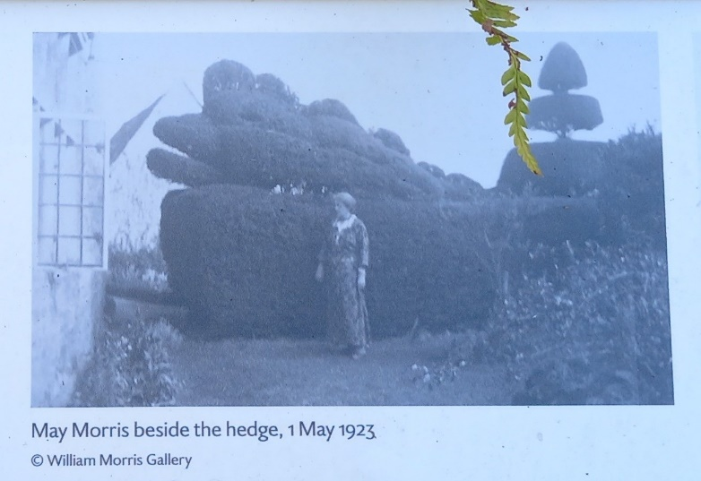

The Fafnir yew hedge
William Morris created the hedge himself. He was a scholar of Icelandic and translated many of the country’s Sagas; inspired by the Volsung Saga, ‘that most glorious of stories’, he clipped the hedge into the shape of Fafnir, the serpent-like dragon killed by the story’s hero, Sigurd. May Morris later recalled how hands-on her father was: ‘we had a merry time of it when he periodically trimmed and shaped the beast – “cutting the dragon’s hair”.’

The hedge became larger and more elaborate over the years. It is gradually being returned to how May would have known it.

“The aim of the long-term restoration project is to recreate the May Morris yew hedge design. Main features include the Fafnir dragon head, a multi-tiered shape halfway down and dome at the end.” (James Todman, topiarist)

The Old Kitchen
Unusually for a middle-class man, William Morris would have known the kitchen and brewhouse well; one of his friends described him as ‘a first-rate cook…who used to say half-jestingly that he could bake bread and brew ale with any farmer’s wife in Oxfordshire.’ To Morris cookery had an important place in the arts of human life; he loved good food, was a knowledgeable judge of fine wines and a genial host.

Much of the Manor’s produce was home-grown; the kitchen garden was on the north side of the house where the croquet lawn is today.

The Brewhouse
The brewhouse is the only space in the Manor’s service wing still recognizable by its original function. With its bread oven, water pump and two coppers (large vats heated from underneath), this space would have been a hive of activity. Servants would undertake the daily and weekly tasks of baking, brewing and laundry in here, where there was ample access to fire and water.

During William Morris’s lifetime the Manor household included a cook, kitchenmaid, parlourmaid, housemaid and ‘between maid’ (known as a tweeny). At least one of the maids accompanied them from their London home.

The brewhouse probably remained central to the domestic life of the house until an unusually late date, as May Morris did not introduce modern conveniences to the Manor, wishing to keep it as it had been in her father’s day.

‘simplicity of life’: The Manor as Morris knew it
‘Everywhere there was but little furniture, and that only the most necessary, and of the simplest forms.’ (William Morris describing a fictionalized Kelmscott Manor in his novel News from Nowhere.)

Morris saw the Old Hall as ‘really the heart of the Kelmscott House’. It was used as the dining room both by generations of Turners, the prosperous farming family who built the house, and later by the Morris family.

The Manor was very simply furnished – so simply that Morris’s wife, Jane, described life here as ‘a continual picnic’. It was a place for friends not for acquaintances, who found its informality a little too unconventional. One complained: ‘The house is lovely for its oldness but oh! so artistic…We sat in a row in the plain, painfully plain dining room.’

The Green Room: Kennet hangings and restful paint
William Morris’s great energy generated many overlapping projects: ‘If a chap can’t compose an epic poem while he’s weaving tapestry…he’ll never do any good at all.’ He produced over 50 designs for textiles alone.

In 1883 Morris began a series of textile designs named after streams flowing into the River Thames, including ‘Kennet’. Alongside them, ‘Strawberry Thief’ brought his focus into the Manor garden itself. He translated his observation of nature into designs with ‘unmistakeable suggestions of gardens and green fields’ that would bring ‘beauty, imagination and order’ to the walls of the Green Room and Old Hall.

The rooms were linked by a scheme of dark green paintwork extending through the ground floor and up to the first floor. This colour, which Morris found ‘restful to the eyes’, gave the room its name.

‘country life was always to us the natural and happy thing’: May’s later years
May was 52 and a respected designer, embroidery historian and lecturer when she inherited the Manor in 1914. She left her London home nine years later to live here permanently.: ‘Miss Lobb and I are going to run the place.’ Mary Lobb was May’s companion from 1917 until the end of her life.

They shared a love of the outdoors and led an active and varied life. For May, embroidery, weaving and writing balanced working outside with Mary. She never lost her sense of the beauty of the place and its setting – its flowers, birds and insects appear in many of her designs.

May was a mainstay of village life; she taught children singing in this room and provided a weekly soup kitchen in the brewhouse, for example. She was fondly remembered by one villager as ‘a very nice, homely lady…You felt at home with her.’

A challenge to the times: The Firm
Morris was alert to the challenges of handmade objects. It enraged him that the skill and creative expression in craft production should be swept aside by the mechanization that defined the Victorian age: ‘Time was when the mystery and wonder of handicrafts were well acknowledged…when imagination and fancy mingled with all things made by man.’

So much of what Morris cared for was about continuity across the centuries before the Industrial Revolution re-set society’s values and compromised artistic standards. He later recalled that ‘all the minor arts were in a state of complete degradation and with the conceited courage of a young man I set myself to reforming all that’ by launching the interior design company Morris, Marshall, Faulkner & Co in 1861.

These tiles, early products of the Firm, embody the fresh creative spirit and individuality Morris valued.

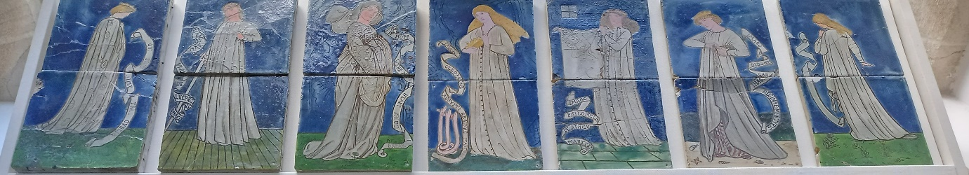

‘The past…is living in us, and will be alive in the future which we are now helping to make.’ (William Morris, ‘The Lesser Arts’, 1877)
‘How Morris seems to know things,’ one of his Oxford University friends exclaimed. He had begun to build his great fund of knowledge at an early age. As a boy, he’d been ‘a great devourer of books’ and a tireless and sensitive observer of the details of old buildings.

The spirit of chivalry and medievalism fascinated him and informed his early poetry and designs. Yet William Morris was original in all he did, and moving freely between different media he created his own hugely influential style in words and pattern, reinventing the past for the present.

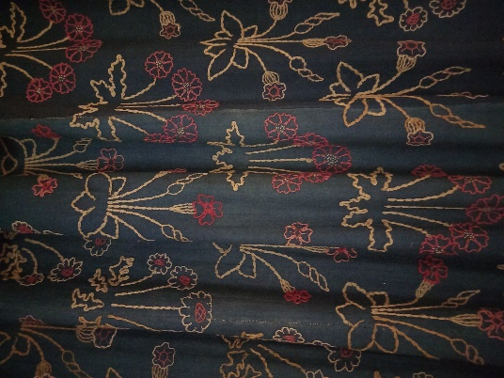
‘Daisy’ wall hangings, 1860
Designed by William Morris for Red House and worked in wool

This was the first project William and Jane worked on together following their marriage and move to Red House in Kent. Jane recalled buying ‘a piece of indigo-dyed blue serge I found by chance in a London shop…I took it home and he was delighted with it and set to work at once designing flowers. These we worked in bright colour in a simple rough way. The work went quickly and when finished we covered the walls of the bedroom…to our great joy.’

Morris adapted the floral motifs from miniatures in Froissart’s Chronicles, a 15th-century French manuscript volume that he knew well.

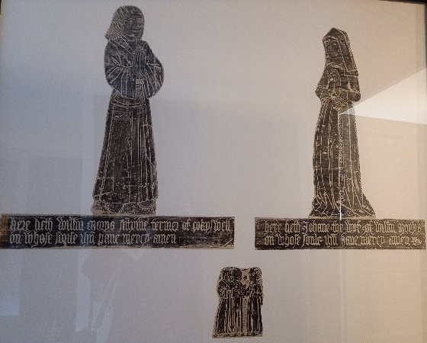
Rubbing by William Morris of memorial brasses, c.1510
William Morris’s fascination for the past began as a boy, through reading an exploring the landscape around his Essex home. So began a lifelong interest in archaeology and an appreciation of humble village churches whose fragile details enchanted and informed him. Over the years he made many brass rubbings.

Whilst exploring ancient buildings and archaeological sites in the locality of Kelmscott, Morris came across a memorial brass in the church at Great Coxwell, nine miles away. It commemorated his and Jane’s namesakes: a gentleman-farmer ‘Willm Morys’ and his wife ‘Johane’. The coincidence, as May Morris tells us, ‘gave great delight. Father took a rubbing of the brass later, and there it is, framed and hanging in one of the lobbies of Kelmscott.’ Morris revisited the church many times, taking friends and guests there.

Layered collections: home or museum?
When William Morris rented the Manor it still contained some furnishings from the Turner family’s time. After he died in 1896, Jane brought many items here from their London home, Kelmscott House. They included the large table and hooded settle, which were both designed for their first family home, Red House, by its architect Philip Webb.

When May Morris made the Manor her permanent home in 1923, she added another layer of contents. Although it was her home she was, in effect, the Manor’s first curator, selecting those items which should remain here when the rest were sold after her death. They reflect her father’s interests as collector, scholar and antiquary, and his roles as designer and writer as well as the furnishing taste of Dante Gabriel Rossetti, co-tenant here for the first three years.

‘amidst green reflections of the gardens’: The White Room
This room, the most formal in the house, was added in around 1665 along with the Tapestry Room above. The Turner family were rising in society, and they remodelled the place in line with the fashion of the day, although their fortunes would falter in the 18th century.

Rossetti used this as a studio. For young Jenny and May Morris it was also a classroom, where ‘we sat…trying to learn things about Roman emperors’. May played truant, preferring to be outdoors. Jenny was more studious, but her bright future was blighted when she developed epilepsy aged 15.

Jenny remained with the family with the support of a nurse companion. She felt the same deep affection for Kelmscott Manor as her parents and sister; as Jane wrote, Jenny ‘never wearies of this place – where she knows every tree and plant’.

‘the best man he ever knew’: Philip Speakman Webb
Architect-designer Philip Webb supervised Morris when he worked, briefly, for Oxford architect George Edmund Street after leaving university in 1856. Morris and Webb became lifelong comrades and associates, reflecting Morris’s belief that ‘fellowship is life’. Webb was a partner when Morris, Marshall, Faulkner & Co was founded in 1861 and, later, a committed fellow socialist.

Webb came many times to Kelmscott Manor. He relaxed by fishing on the Thames with Morris and enjoyed the company and liveliness of Jane, Jenny and May. He also advised on repairs and alterations to the old house. He designed this shelving, which echoes that in the dining room at the Morrises’ London home, Kelmscott House.

Having designed Morris’s first married home in 1858, Webb also designed the gravestone for his friend’s final resting place in Kelmscott’s churchyard.

‘all delightful and home-like to me’: Jane Morris and Kelmscott
Jane Morris came from a working-class background in Oxford. Intelligent and motivated, she adapted quickly to life as Mrs Morris. She ran her household capably, read widely, learnt both French and Italian, and played the piano and mandolin. A highly skilled needlewoman, she supervised the Firm’s embroidery department: ‘we were making experiments…afterwards to bloom into our altar cloths’.

Jane found the Manor ‘the very spot for full poetic enjoyment’, taking riverside walks and delighting in the garden: ‘I can almost see flowers grow, cherry-blossom just bursting’. In 1899 she made a practical contribution to Kelmscott, commissioning Philip Webb to design two cottages, one of them with a men’s Reading Room.

Friends remembered Jane’s enquiring mind, kindliness, sense of fun and unfailing care of her daughter Jenny. She was far removed from the Pre-Raphaelite image that has defined her.

‘only don’t paper new plaster’: New decorative schemes
With her husband away in Iceland over the summer of 1871, Jane supervised alterations and decorations to make the house more home-like, ordering wallpapers from the Firm and consulting Philip Webb about other matters.

A photograph of this room shows this very feminine scheme, which combines ‘Small Stem’ bed hangings and Morris’s ‘Fruit’ wallpaper. In 1868, when first considering textile production, Morris had approached a print works in Lancashire to enquire whether the blocks used for their earlier products were still available. ‘Small Stem’, designed in 1829, was one of several textiles to be printed for Morris, Marshall, Faulkner & Co as a result.

William Morris was born in this bed. It was designed at a similar date to ‘Small Stem’, so the choice of upholstery seems to have been carefully considered.

‘the thing most to be longed for’: Morris as collector
Morris was a born collector, both of modest country-made objects and items of rarity and intricate workmanship. The things he chose to have around him reflected the breadth of his interests and the enduring curiosity that characterized him as a scholar and antiquary.

In his later years Morris was a determined collector of early printed books and manuscripts, building up an extensive library that also contained 18th- and 19th-century titles on history, architecture, archaeology, customs and cultures, and natural history. He was first enthused by antiquities as a boy: ‘I remember…thinking that the gates of heaven had been opened to me…when I first saw an illuminated manuscript.’

Most of Morris’s library was dispersed after his death but the books the family retained are in the Manor collection. Many are volumes he gave to Jane, Jenny or May.

William Morris’s bed at Kelmscott Manor
William Morris loved this bed so much that he wrote a poem for it. May Morris sewed the poem around the top of the bed for him. The bed has its own voice in the poem and ells the reader to rest.

For the bed at Kelmscott
The wind’s on the wold
And the night is a-cold,
And Thames runs chill
Twixt mead and hill.
But kind and dear
Is the old house here
And my heart is warm
Midst winter’s harm

Rest then and ret
And think of the best
Twixt summer and spring
When all birds sing
In the town of the tree;
And ye lie in me
And scarce dare move
Lest earth and its love
Should fade away
Ere the full of the day.

I am old and have seen
Many things that have been
Both grief and peace,
And wane and increase,
No tale I tell
Of ill or well
But this I say
Night treadeth on day
And for worst or best
Right good is rest.

‘it is our best sitting-room now’: a live/work space
Originally a bedroom, this was a second studio for Rossetti. For the Morris family, it doubled up as a workspace and somewhere to relax. ‘The fire, the draught board, the kittens, & mother Janey coiled up on the sofa,’ Philip Webb recalled.

With a backdrop of farm activity marking the cycle of the seasons, Morris designed textiles and wallpapers in here. From 1890, prose romances and designs for his last great venture, the Kelmscott Press, took up his time: ‘my husband is getting on fast and well with his new book, by sitting up late, one night he worked till dawn.’

Later, from 1906-15, May Morris spent many hours in here working on the 24-volume Collected Works of William Morris. The introduction she wrote for them tell us much about the details of life her during her earlier years.

The romance of the Tapestry Room
‘I have heard people mis-called for being romantic, but what romance means is the power of making the past part of the present.’

‘The walls of it are hung with tapestry…representing the story of Samson; they were never great works of art, and now when all the bright colours are faded out, and nothing is left but the indigo blues, the greys and the warm yellowy browns, they look better, I think, than they were meant to look: at any rate they make the walls a very pleasant background for the living people who haunt the room…in spite of the designer, they give an air of romance to the room which nothing else would quite do.’ (William Morris on the Tapestry Room in his 1895 article ‘Gossip about an Old House on the Upper Thames’)

‘my studio was hung with tapestry’: Rossetti at Kelmscott Manor
In July 1871, during his first summer here, Dante Gabriel Rossetti called it ‘the loveliest place in the world’. He and Jane enjoyed long walks together, and Jenny and May were ‘dear little things’ who kept themselves amused. He was inspired creatively, producing highly personal works: portraits of Jane and the girls and a ‘little ballad suggested by the riverside surroundings’. Other poems and pictures followed.

He returned in September 1872 following a nervous breakdown. He found the peace and routine helpful. ‘I have done nothing but my daily painting all my time here’. However, the magic of the previous year was never quite recaptured, though friends and family came to visit, as did Jane and the girls.

By spring 1874 Rossetti was suffering from sleeplessness and hallucinations. He left the Manor, returning to London on 11 July, exactly three years after his arrival.

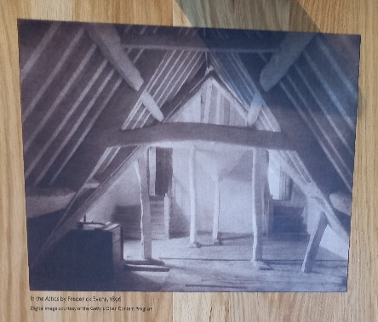
Frederick Evans: a photographic portrait of Kelmscott Manor
William Morris was a regular at Frederick Evans’s bookshop, a hub for London’s writers and esthetes. The two shared a love of books, passion for collecting and a deep appreciation of medieval architecture. Evans’s Kelmscott Press editions were the pride of his extensive library.

Evans – bookseller, writer, lecturer – was also an accomplished photographer and gave up business to devote himself to it. Morris admired his artistry in capturing the spirit of place through close observation of shifting atmospheric effects at different times of day.

Evans was the natural choice when Morris wanted a photographic ‘portrait’ of the Manor and its setting. In spring 1896 they spent a week here and may have collaborated over some of the resulting 31 photographs. The interplay of light and texture evokes the serene and spiritual quality of this ancient space.

The Attics
As children, Jenny and May Morris spent a lot of time in these attics. This was a place for exploring, sleeping and playing – somewhere they could make their own. May Morris was adventurous, and she used to climb out of a little hatch leading out onto the roof to go roof-riding. Once she got stuck and had to be rescued with very long ladders!

‘We went in, and found no soul in any room as we wandered from room to room – from the rose-covered porch to the strange and quaint garrets amongst the great timbers of the roof…which…now, by the small size of the beds, and the litter of useless and disregarded matters – bunches of dying flowers, feathers of birds, shells of starlings’ eggs, caddis worms in mugs, and the like – seemed to be inhabited for the time by children.’ (William Morris, extract from News from Nowhere)

The ’Homestead and the Forest’ quilt
This extraordinary quilt for a child’s bed, with playful representations of Kelmscott Manor and the Thames, was designed by May Morris shortly before her marriage, perhaps intended for the child she never had. It was embroidered by Jane Morris. When exhibited in 1890 it was praised for its originality.

May used her father’s library for inspiration, several of the animals and birds are adapted from illustrations in books he owned, as are most of the quotations and proverbs that reflect the socialist principles they shared.

May kept the quilt until her death in 1938. In curating the Manor as a memorial to her father, she did not include examples of her own work, and the cot quilt was sold. The Society of Antiquaries acquired it in 2016 to represent May more fully in the Manor’s story.

A Horse called Mouse
‘Mouse got enormously fat on our coarse thick plentiful English grass, with little to do; and I used to imagine him lonely, and yearning for the fun and clatter and hardships of his Icelandic life amongst his friends.’ (Jenny or May Morris)

In 1871 this dovecot was adapted for a new occupant – ‘the bravest and best-tempered of beasts’ was a sturdy little, red-coloured horse called Mouse, brought back from Iceland by William Morris for his daughters. To May he was ‘no mere animal in the Kelmscott life, but a personality’, loved by every member of the family.

When he wasn’t munching grass and watching out for passers-by from the paddock beside the gardener’s cottage, Mouse was ridden by Jenny, May or their father. He was also taught to pull a lightweight basket-carriage ‘between the shafts of which he looked incredibly fat and funny.’

‘We grieved at his death, and the home-close wore a blanket air for a long time when he had gone.’ (May Morris)

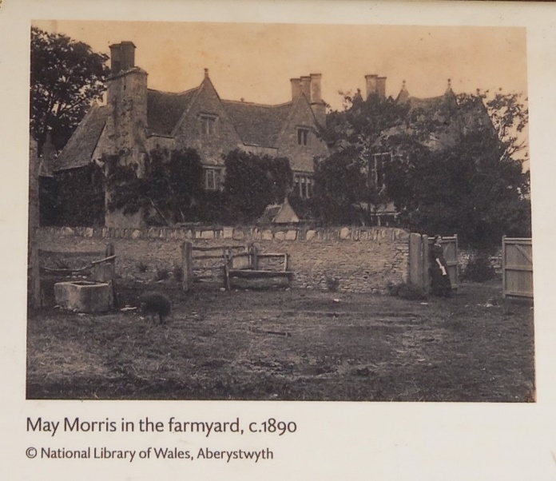
Animal husbandry and animal rights
The Morris family household raised animals for food as well as keeping them as pets; they had home-cured bacon and ham from the pigs, and eggs from their ducks and chickens.
Livestock here was treated with kindliness and respect. Once, Morris’s day was interrupted by some adventurous ducklings who ‘went too far up the ditch and had to be…brought back again for all the world like naughty children.’ When the Manor flooded, the hens were kept safe up in the attics.
Even as a girl May had felt compassion for the unhappy fate of many Icelandic horses: ‘sold…to go down into the mines, where they never saw daylight again – the squalor, the desolation of it.’ Later, May and Mary’s social circle included many who campaigned against cruelty to animals, including Henry Salt, ‘father of the animal rights movement’, and founding members of the League for the Prohibition of Cruel Sports.
‘Our friend and neighbour’: farmer and tenant
Over the years, farm life carried on alongside the life the Morris family enjoyed here: pigs in the farmyard, haystacks where the Tea Lawn is now, sheep, crops and cattle in the fields round about.
There was a ‘common interest and common understanding’ between William Morris and Robert W Hobbs of nearby Home Farm. His father, Charles, had inherited the Manor from the last surviving member of the Turner family. Hobbs was progressive, admired by stock-breeders across the globe for his herd of dairy shorthorn cattle.
The friendship between the families continued into the next generation, often to the benefit of the village’s cultural and physical wellbeing. Hobbs’s daughter-in-law May Elliott Hobbs was a close friend of May Morris. Energetic and forward-thinking, the pair founded the Kelmscott Women’s Institute in 1916.
May, Mary and their pets
‘July 16th We started for the Outer Hebrides. I distinguished myself by crying all the way to the station & most of the way to Oxford for the last farewell to Buzzy.’ (May Morris in her 1929 travel diary)

Animals were part of the Morris household at Kelmscott Manor. In her later years, the pets May Morris shared with her companion Mary Lobb – a great animal lover – were much-cherished members of the family, mentioned in letters and diaries and recorded in photographs. As well as several cats and Buzzy Dog, they kept goats, and a fine Arabian horse called Astola.
‘We have both been unwell all Christmas, but it was rather jolly too, cooking our Goose and Pudding and playing with the cats.’ (May Morris, 1924)
William Morris, revolutionary socialist:
‘To do nothing but grumble and not to act – that is throwing away one’s life.’
1877 saw Morris emerge as activist and public speaker, delivering lectures such as ‘How We Live and How We Might Live’ and ‘Useful Work Versus Useless Toil’.

Morris was a businessman and manufacturer. He was well-placed to appreciate that social equality and creative fulfilment were impossible in a capitalist system that thrived on exploitation. In 1883 he ‘crossed the river of fire’ and joined England’s first official socialist party, the Social Democratic Federation.

Kelmscott played its part. In the face of opposition from landowners and farmers, Morris and fellow socialist Oswald Birchall, vicar at nearby Buscot, worked to inform and inspire local agricultural workers. And it was to the landscape and architecture of his beloved Kelmscott that Morris turned in formulating his vision of post-revolutionary England when he wrote his great Utopian novel News from Nowhere in 1890.

The future is now: local impacts
Uffington White Horse was dear to Morris’s heart. It is 13 miles from Kelmscott and he visited it annually. In his mind’s eye the landscape was alive with the people who created it. He felt connected to them through respect for the earth. It was a ‘country-side worth fighting for…worth taking trouble to defend its peace.’ With sadness he noted the contrast between the glories of nature and noble relics of the past and the drudgery and exploitation inherent in capitalism.

It was with an uncanny foreboding that Morris saw how vulnerable the countryside was.: ‘The beauty of the landscape will be exploited and artificialized…in quiet places like this it will vanish year by year (as indeed it is now doing) under the attacks of the most grovelling commercialism.’

Morris matters now: eco-socialism
Morris was dismayed by the environmental impact of industrialization: ‘our green fields and clear waters, nay the very air we breathe are turned…to dirt…things grow worse year by year, day by day. Let us eat and drink, for to-morrow we die – choked by filth.’

In Morris’s unique vision, politics embraced the arts, history and ecology: a classless society of citizens freed from the tyranny of profit-making, living fulfilled and dignified lives in harmony with each other and with nature. His ideal was a society that has moved beyond the vicious circle of capitalist commercialism: ‘there will be no compulsion on us to go on producing things we do not want, no compulsion on us to labour for nothing.’ He asks us to look at ourselves.

Morris is hailed today as one of the first eco-socialists because of his clear-sightedness that social equality and respect for the natural world should go hand-in-hand and are, in fact, interdependent.

How I Became a Socialist
‘Apart from the desire to produce beautiful things, the leading passion of my life has been and is hared of modern civilization.’

When he wrote ‘How I Became a Socialist’, William Morris, with his deep love of the earth and the life on it, asked whether it was all to ‘end in a counting-house on the top of a cinder-heap?’ He embraced ‘practical socialism’ because he saw that ‘the seeds of a great change, what we…call Social-Revolution, were beginning to germinate.’

‘…what I mean by Socialism is a condition of society…in which all men would be living in equality…and would manage their affairs unwastefully, and with the full consciousness that harm to one would mean harm to all – the realization at last of the meaning of the word COMMONWEALTH.’ (‘How I Became a Socialist’ by William Morris, 1894)

William Morris and Iceland
Morris already had a longstanding interest in Icelandic literature when he met scholar Eiríkur Magnússon in 1868 and began reading and translating under his guidance.

During his visits (1871 and 1873), Morris and his companions crossed Iceland’s daunting interior on horseback, visiting Saga sites. His designer’s eye saw beauty in the detail of the landscape – tiny bright flowers ‘like a Persian carpet’, for example. He felt a natural sympathy with the economically poor Icelanders, who were ‘gentle, kind…full of their old lore’, their lives enriched by oral and craft traditions that still persisted. Here, all were equal, in contrast to class-ridden England.

His Icelandic experiences had a profound effect on Morris’s thinking about art and society. His identification with the Saga heroes’ quality of ‘deedfulness’ – acceptance and hope through resolute activity – shifted his perspective on life. He returned determined to ‘look at things bigly and kindly’.

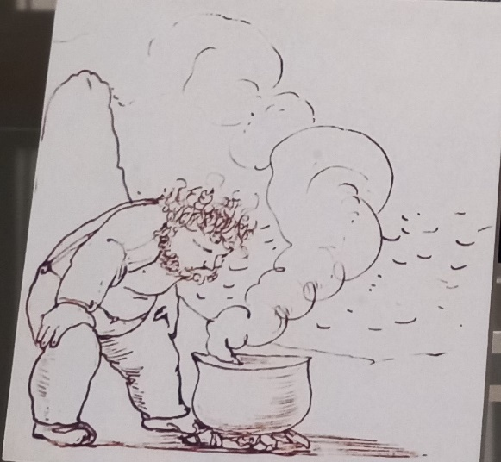
William Morris cooking in Iceland by Edward Burne-Jones
©British Library

To prepare for his first trip to Iceland, where travel would be by horse, Morris went riding regularly. He was interested in cookery and looked forward to acting as camp cook; in anticipation, he ‘built a lite hearth in their garden with loose bricks, over which he cooked a stew in the manner of some pirate or backwoodsman in a story-book.’ Once in Iceland, although he disliked having to shoot game, he relished his role as cook. The first meal he made was plover stew, and: ‘the results were surprising even to me who suspected my own hidden talents in the matter.’ Three weeks later, he wrote to Jane: ‘You’ve no idea what a good stew I can make, or how well I can fry bacon under difficulties.’

May Morris and Iceland
What began as merely a ‘spot on the map’ became in 1871 part of the fabric of the home when Morris brought back mementoes like wooden items and traditional costume for Jane and the girls.

May visited Iceland three times, following in her father’s footsteps. She and her companion, Mary Lobb (‘M F’), prepared for their first trip in 1924 by camping in the Yorkshire Dales and taking language lessons. Like her father, May responded to the landscape ‘at once overpoweringly beautiful and overpoweringly melancholy’, the people’s kindness, and the handcrafted items that beautified humble but cultured homes. She appreciated the home-industries of Iceland, especially its textile crafts.

In another parallel, May maintained strong links with Iceland through friendships and practical support: her father had promoted the Icelandic Famine Relief Fund; she sent books for its libraries. May was awarded Iceland’s highest honour, The Order of the Falcon, in 1930.

‘The modern touch’
Social and Technological Change
The decades between the 1870s and the 1920s saw enormous change in Iceland. In 1874, Denmark granted it its own constitution; Home Rule was established in 1904, and in 1918 Iceland became a sovereign country. The same year, women’s suffrage was achieved.

Reykjavik, its population around 2,000 in 1870 and nearly 20,000 by 1920, had grown into a modern capital. New buildings had sprung up next to older wooden or corrugated iron-clad houses, streets were paved, electricity was introduced in 1922, and the motor car had arrived too. To May, this ‘modern object’ was somewhat out of place in a country that seemed frozen in time in other respects. She preferred the leisurely rhythm of travel by horseback: ‘modern travel seems so complicated’, she lamented, ‘in 1871 your poneys started in Reykjavik from your very door, and there you are well on your travels.’

In the countryside, age-old ways of life co-existed alongside innovation. Telephone poles, new roads and bridges for automobile traffic were visual indications of modern times, as were the concrete houses steadily replacing the older turf-roofed farmhouses, ubiquitous when William Morris had visited. Inside peoples’ homes, traditional crafts were still widely practised, though on one occasion May was proudly shown a knitting-machine. Although she appreciated that mechanization improved Icelanders’ lives, she found new building styles and other changes jarring and, at times, ugly.

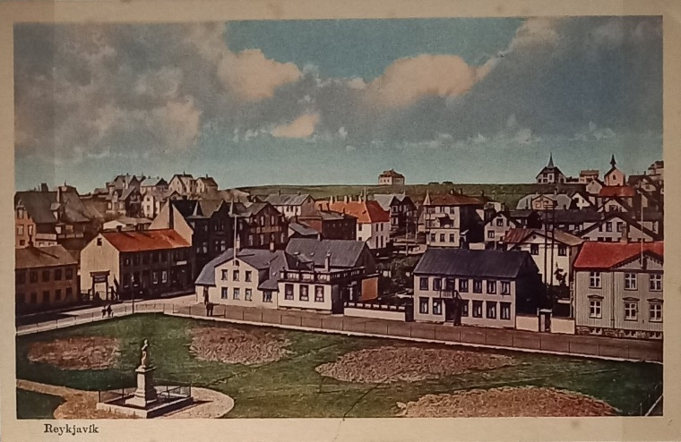
Postcard of Reykjavik, 1920s
©Society of Antiquaries of London (Kelmscott Manor)

Reykjavik
William Morris described Reykjavik as ‘a commonplace-looking little town of wood principally…ashore we go and land in a street of little low wooden houses…with white sash frames; the streets of black volcanic sand; little ragged gardens about some of the houses.’

May noted many changes (‘all so different from Father’s time!’), but enthused: ‘Reykjavik…is built now of stone and wood and concrete and corrugated iron…The aspect of modern Reykjavik houses is fantastic but really rather pretty…each one looks as if designed to an individual fancy…some are long, some tall; some have towers…some sport tin dragons and some have Eastern cupolas…All are neat and clean and all have flower gardens in the windows.’

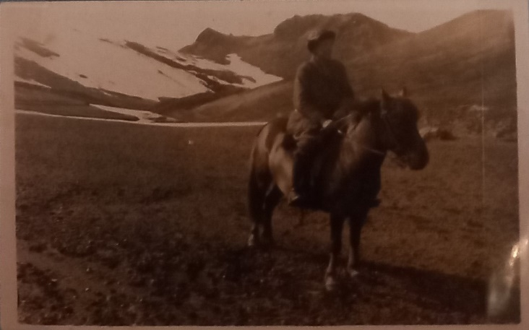
Photograph of May Morris with her horse
©Society of Antiquaries of London (Kelmscott Manor)

Transport
‘I…enjoy the riding very much; the poneys are delightful little beasts, and their amble is the pleasantest possible means of travelling’ wrote Morris. May and Mary relished it too: ‘oh the joy of scampering over the wild…Just ourselves and the friend-poneys.’

May regretfully observed that travel ‘seems a little complicated…owing to the combination of motor and riding…I sigh for the old days’. In Morris’s time, Iceland’s transport infrastructure was rudimentary; at Reykholts-dale ‘we came among most evil bogs, and the road dying out among them, as commonly happens, we fairly lost our way’. Although May acknowledged the ‘cleverly engineered roads’ made or extended by the 1920s meant more efficient travel, the nature of the experience had lost something: ‘Hurrying in this stupid way in a car one’s impressions are blurred and a little mixed’.

Housing
William and May’s descriptions capture the contrast between the older turf, stone and wooden houses – characterful, each adapted to its landscape setting and part of an ancient building tradition – and those that were rapidly replacing them. At Oddi, for example, Morris describes: ‘a six-gabled house of the regular Icelandic type, turf walls ever so thick, and wooden gables facing the sunny side…little white framed windows with small panes of glass in them: both walls and roof are just as green as the field they spring from.’ In 1931, at Ekkjufell in eastern Iceland, May writes sadly of the evident change: ‘this is a desolate concrete house in a beautiful place & I kept picturing the charm of the previous building among the green.’

‘A cordial welcome’
Hospitality and Friendships
Both William and May Morris had a network of Icelandic friends and acquaintances who helped them with their travel arrangements. Since Eiríkur Magnússon travelled with William in 1871, they had easy access to Icelandic homes, sometimes staying with farmers and their families, or camping beside farmhouses. The itinerary that May and Mary followed in 1924 was largely put together by an Icelandic politician, Jónas Jónsson, who had arranged guides and provided introductions to his friends and contacts around the country.

In Reykjavik, May and Mary were almost overwhelmed with social invitations. By the 1920s, a vibrant cultural life had grown up in this small capital city. In 1908 the National Library and National Museum had moved their collections into the newly-built Safnahús, the University of Iceland had been founded in 1911. The Icelandic fine art scene was also gaining recognition, and both theatrical and musical performances were held regularly. Social and political movements, such as the women’s movement and temperance movement, were also part of urban life. Leading cultural, social and political figures reached out to May and Mary and received them warmly. They met with similarly kind and hospitable treatment in the rural areas they visited.

‘Mountains and plains and adventure’
William & May Morris and Iceland
‘Nothing I have ever seen has impressed me so much’ wrote William Morris of Iceland. He felt the pull of the country as he learned its language through translating its saga-stories. Leaving business and home-life behind, he went there twice (1871 and 1873). The combination of its society, literary landscapes and aesthetic had a profound effect on him that would reverberate through his future work and thinking.

Fifty years later his daughter, May, was finally able to fulfil her dream of experiencing the land that had come to mean so much to her father and which, through his enduring fascination with it, had been part of her life since she was a girl. Accompanied by Mary Lobb, the life-companion of her later years, in 1924 she set sail. They would return to Iceland again in 1926 and 1931.

Like her father, May kept diaries of her travels in Iceland, writing about people and places she and Mary encountered. These uniquely vivid and informal accounts – she had a lively writing style, informed eye, and a knack for making friends – remained undiscovered until they were acquired by Kelmscott Manor in 2018. They underpin this exhibition, making it possible for the first time to compare William and May Morris’s Icelandic experiences through their own words. Neither the diaries themselves, nor many of the photographs they contain, have been on public display before.

‘A new land at last to be seen’
Motivations and Preparations
William Morris was a self-styled ‘man of the north’; his prime motivation for visiting Iceland was its literature and the ‘history worthy of its strangeness’ at the remotest margin of Europe. He was already steeped in the country’s sagas through his work with friend, mentor and co-translator Eriikur Magnússon from 1868. The country drew him, not as a tourist, but as a poet anticipating ‘the most romantic of all deserts’.

May Morris was well-versed in the literature and turbulent history of Icelandic society. As her father had done, she set off determined to discover the authentic Iceland, following in his footsteps through landscapes that echoed with the drama and turmoil of the sagas.

Both father and daughter prepared systematically, reading widely, and paying particular attention to the physical demands camping and travel on horseback would entail. They each undertook experiments in preparing food outdoors, for example, and in May’s case (along with Mary), living under canvas and testing carefully-researched rations for a week in a remote corner of North Yorkshire.

‘Precious household goods’
Experiencing the Domestic
Both William and May Morris had an abiding interest in material culture; they were each uniquely equipped to appreciate Icelanders’ domestic interiors with the discrimination of designer, maker and antiquary combined. In 1871, the privileged access that came with having a well-connected Icelander as a travelling companion meant that Morris spent time, or stayed overnight, in upwards of thirty houses whilst travelling round.

William Morris was especially interested in the hand-made, which in England had already been undermined by expanding mechanization, and his descriptions as he appreciates and appraises furniture, jewellery, domestic utensils, books and textiles are filled with pleasure in their everyday-ness and authentic contextualization.

May took equal delight in the homes of her Icelandic hosts and the sense that, in so many of them, necessity and creativity habitually went hand-in-hand; she described them as ‘full of refinement and little elegances, and books of course.’ She took particular interest in the textile crafts. With her first-hand knowledge of the technicalities of spinning, weaving and embroidery, as she came across them she recorded processes and equipment as well as the finished products.

‘Storied places’
Reading Saga Landscapes
The sagas are a literary genre rooted in place, dramatic narratives describing the 9th-century settlement of Iceland and the lives of the first generations of Icelanders. Written down in the 13th century, the texts sketch how a new society established itself, describing the achievements of individuals and communities, and tensions that flared up into violent feud. The sagas’ action played out across Iceland: on family farms, at assembly sites, and in the wild central highlands.

In the 19th century, several sagas were translated into English, becoming popular reading, and Iceland became a tourist destination for the wealthy and culturally minded. William and May Morris, with their deeper appreciation of the sagas, went in search of something more. Both observed how past events still resonated, with May writing: ‘Everywhere, as my Father found in his day, as you pass a famous site, the country-folk will tell you of the family living there once or the scene enacted there, as though all were of yesterday and the actors, as it might be, ancestors of themselves.’ Treading in her father’s footsteps through the saga landscapes, knowing from his journal how he had responded to them, was immensely meaningful to her.

Poems by the Way by William Morris
Kelmscott Press, London 1891
Paper, vellum binding with linen ties
KM Cat. 187
Society of Antiquaries of London (Kelmscott Manor)

Poems by the Way include a number of poems with Norse and Icelandic subject-matter, amongst them Iceland First Seen. At 3am on 13th July 1871, Morris was woken by Eiríkur Magnússon and went on deck as the Diana sailed past the south-east corner of Iceland in the dawn light. It was a momentous moment; his journal entry begins: ‘So I have seen Iceland at last’. He looked upon it with ‘infinite wonder’.

Morris’s poem captures the drama of the rocky coastline and the stark history enfolded by it. In 1872 it was published in Ny Fèlagsrit, a well-established Icelandic periodical, and would have been read by many Icelanders before Morris returned in 1873.

The Roots of the Mountains by William Morris
Reeves & Turner, London 1889
KM Cat. 104
Society of Antiquaries of London (Kelmscott Manor)

The Roots of the Mountains was largely written in the seclusion of Kelmscott Manor, with Jane noting that ‘we have been quite alone with work…my husband is getting on fast and well with his new book, by sitting up late, one night he worked til dawn.’

Tolkien had developed an admiration for Morris’s Icelandic translations and prose romances as a student at Exeter College, Oxford (Morris’s old college). He later acknowledged his debt, especially to The Roots of the Mountains, which was a direct influence on The Lord of the Rings, from its landscapes and placenames to characters and concept of community. The phrase ‘roots of the mountains’ recurs in several of Tolkien’s novels, including The Hobbit.

The Story of the Glittering Plain by William Morris
Kelmscott Press, London 1894
Illustrations by Walter Crane (1845-1915)
Paper; vellum binding
KM Cat. 211 (A2)
Society of Antiquaries of London (Kelmscott Manor)

Towards the end of the 1880s William Morris embarked on writing an extraordinary series of prose works inspired by sagas – tales of myth and heroism now considered amongst the first fantasy novels. These prose romances exerted enormous influence on the 20th century’s great fantasy writers C S Lewis and J R R Tolkien. Lewis had first discovered them as a 16-year-old, later declaring: ‘I wish he had written a hundred of them!’ He considered them ‘the real crown’ of Morris’s work. Via Morris, dramatic elements of the Icelandic landscape and what Lewis referred to as ‘Northernness’ made their way into his fictional worlds, including Narnia.

The Earthly Paradise, Vol. I by William Morris
Kelmscott Press, London 1896
Paper, vellum binding with linen ties
KM Cat. 86
Society of Antiquaries of London (Kelmscott Manor)

Morris’s critically acclaimed epic poem, published in several parts between 1868 and 1870, is 48,000 lines long. It is constructed as a collection of Classical and Norse myths and legends recounted by The Wanderers, medieval Norsemen fleeing the Plague in search of a land of immortality.

Morris met Icelandic scholar Eiríkur Magnússon in 1868 and asked to be tutored in the language, though he refused to be taught grammar, declaring: ‘You be my grammar as we go along!’ Thus began a period of several years during which writing and translating Norse literature became one of his chief preoccupations.

‘Dusk that shall never be dark’
Recognition and Legacy
The Morrises’ ongoing practical support of the Icelanders after they returned to England – William through his efforts for the Famine Relief Fundin 1882-83, for example, and May with substantial gifts of books for Icelandic libraries and donations to the National Hospital building project – reflected the deep-rooted relationships that had been forged. The legacy of their Icelandic experiences was to be felt in the sphere of home-life, in unlooked-for recognition from the Icelandic nation, and in more far-reaching ways.

The profound influence of Morris’s later prose romances (a creative progression from the sagas) on 20th-century writers such as J R R Tolkein and C S Lewis gave rise to a significant literary legacy.

In the sphere of antiquarianism and archaeology, artist and antiquarian W G Collingwood was prompted to follow Morris and visit the saga-sites of Iceland in 1897 with Jón Stefánsson. Collingwood documented the places he saw by making hundreds of paintings and drawings. He went on to become a leading authority on the Vikings in England’s Lakeland.

Legacies are seldom static, and the Morris legacy continues in many forms. This exhibition, informed by May Morris’s rich and vivid Icelandic diaries, has shed new light on a place, a people, and the life-affirming impact they made on her; we hope it will also mark a new phase in May Morris’s evaluation in the country she held so dear.

